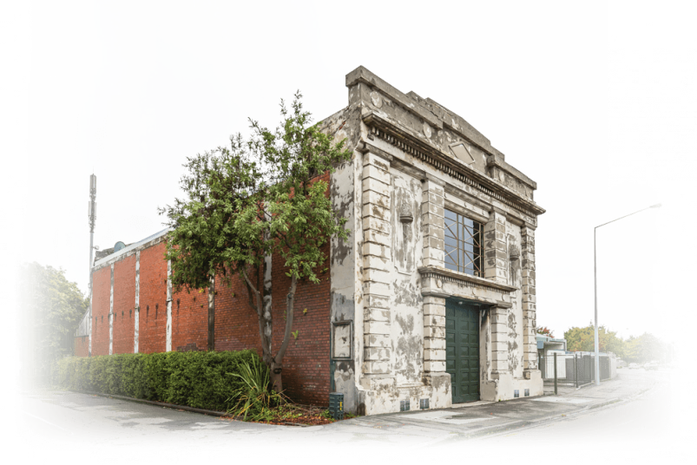
Funded projects
Heritage EQUIP was a special government fund that helped strengthen privately owned earthquake-prone heritage buildings.
Find out about projects that funding was awarded to.
2016–2020

Contents

3 Case studies

Find out what other building owners have done to strengthen their buildings.

40 Other funded projects

Information relating to 77 projects that Heritage EQUIP funding was awarded to between 2017 and 2020.

Case studies
Find out what other building owners have done to strengthen their buildings.

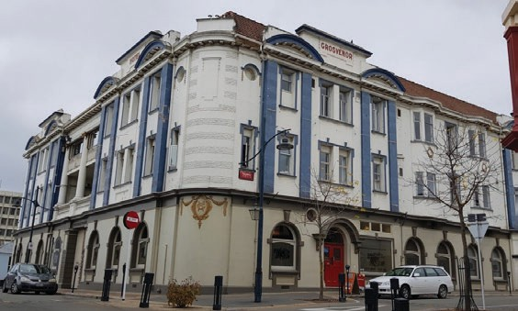
CANTERBURY

The Grosvenor, Timaru
A large masonry-built hotel with a heavy roof posed challenges for the owner, their engineers, and for heritage experts. Ping Lim and his project team are ready to respond.
Structural engineer:
Davis Ogilvie & Partners
Date funded: July 2019

The Grosvenor among the first professional advice
grants
The Grosvenor Hotel has been a much-loved feature of the streetscape of Timaru for 104 years. During this time, it earned the moniker ‘the Grand Old Lady of the South’. Owners Polladio Holding Limited are pleased
to have been awarded a Heritage EQUIP Professional Advice grant. The grant was one of the first five Heritage EQUIP Professional Advice Grants awarded. The owners will use the $29,100 to secure structural design from engineers Davis Ogilvie, a peer review from Batchelar McDougall Consulting and consent processing assistance from Avanzar Consulting.

Historic hotel gains a new life
The Grosvenor Hotel was constructed in 1915. It replaced a previous hotel with the same name which had occupied the site since 1875. Both hotels have made unique contributions to the history of Timaru. The
Canterbury Rugby Football Union (CRFU) was established in the basement if the original building in 1879. The Grosvenor there today hosted Queen Elizabeth during a royal visit in 1954 and again in 1970s. Since 1983 the hotel has been recognised by Heritage New Zealand Pouhere Taonga as a Category II historic place.

When Polladio Holdings Limited bought the building in 2005, it was looking tired and somewhat neglected. The new owners were keen to uncover the original brickwork, kauri and rimu flooring and panelling. Ping Lim from Polladio Holdings Limited says he likes ‘the creaking old floorboards, uneven wall lining, and a different layout for every room’. He saw the interior as a blank canvas – literally. In the past 14 years, the Grosvenor has become home to a substantial art collection that includes works by eminent New Zealand artists Bill Hammond, Peter Robinson,
Hannah Kidd, Lonnie Hutchinson, Jim Cooper and Ian Scott. International

4

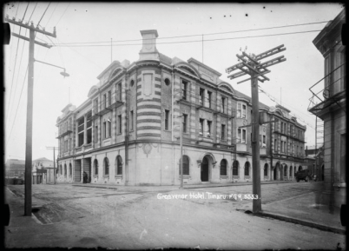
artists like Melly Trochez and Leo Eguiarte also feature throughout the hotel, and its popular restaurant and bar.

Grosvenor Hotel, Timaru. Ref: 1/2-006876-G. Alexander Turnbull Library, Wellington, New Zealand.

Structural challenges
Seismic assessments already completed for the building highlighted the challenges posed by the sandstone and brick façade. The exterior walls need stronger resistance to earthquake face loads and the parapets require tying into the roof structure. These are common challenges for masonry buildings.

Another challenge identified is the weight of the Marseille tile roof. Lim half-jokingly notes that the tile choice back in the day was likely because of locals referring to Timaru as “the Riviera of the South”. He has engaged with Heritage New Zealand early and often to ensure he and his structural engineers have the best guidance on keeping heritage to the fore during design. For their part, Heritage New Zealand have been happy to provide high-level advice as it will help when it comes to consents for the eventual upgrade work.

Lim also operates the hotel business and he plans to keep the building open during most of the upgrade work. This will retain much of the building’s income and helps with overall project viability.

Future
Lim says that the Grosvenor is ‘all about bringing people together’. This was critical in establishing the upgrade project team, and he hopes that the upgrade will both remind locals about their shared history and meet their town’s changing needs. Once the upgrade is complete Lim’s plan is to in- crease occupancy at that the Grosvenor and have the building’s past come alive for visitors to Timaru and locals alike.
Heritage EQUIP Funded Projects 5

CANTERBURY

Milton Street Substation, Christchurch
When Clark Mauger went to view the earthquake-prone Milton Street substation in Sydenham, he immediately knew he wanted to restore the building to its former glory.

Industrial beginnings
The Milton Street substation in Sydenham was built in 1928 by the Municipal Electricity Department (MED) and designed by the company’s own draughtsmen. The decorative style of the substation was probably chosen in order to please local residents, who complained that such buildings were ‘disfiguring the city’.

Nowadays, it is the largest remaining example of the ornamental, classically-influenced substations built in Christchurch during the art deco period, and is listed as a significant heritage site in the city’s district plan.

Structural engineer: Kate de Bruin, RedFox Engineers
Architect:
Fulton Ross Team Architects Ltd
Date funded: May 2018
Seismic works budget: $370,000
Project duration: 10 months
Seismic strength addressed: Installation of structural steel brace framing, strengthening the street facing parapet, and tying the brick masonry infill walls.
Expected completion date: mid-2019
Building owner: Clark Mauger
The substation is also a reminder of the importance the introduction of reticulated electricity had in New Zealand: offering people a clean, efficient and economical energy source for their households and commercial activities.

Christchurch was fortunate in this respect. It was the first city in the country to benefit from the construction of a major state hydro-electricity scheme, at Lake Coleridge, which began supplying power to the city in 1915.

During the second half of the twentieth century, the substation became obsolete and was replaced. Eventually it was repurposed as a commercial building and was occupied by a joinery business for a number of years.

For sale: a local landmark
When the Canterbury Earthquakes struck in 2010 and 2011, the former substation suffered some damage: although the damage to the main structure was only minor, the side parapets collapsed and a rear extension suffered significant damage.

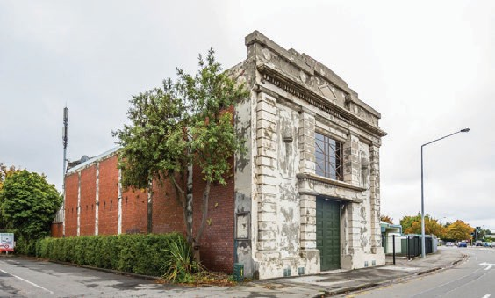
6

Following a detailed engineering evaluation, the building was deemed earthquake-prone and unsafe to occupy. Despite this, the building retained many of its original features, including character windows, a torch lamp motif on the façade and high-stud timber ceilings.

In 2017, the building was put up for sale. Clark Mauger went to view it – and immediately put in an offer:

“I saw the listing pop up on Trade Me, called the agent straight away and made sure I was the first person through it. After the viewing, I was driving home and thought ‘opportunities like this don’t come along every day.’ So I did a U-turn, called the agent and said ‘I’m on my way to your office to put an offer in.’”

“My offer was accepted and the journey began. And a long journey it has become!”

“A few weeks later, I was looking through some old goal setting sheets I had done years earlier. Incredibly, on one of them it said ‘own an MED substation’. I had completely forgotten about that goal – but it must have been sitting in my subconscious all that time. It was just meant to be, I think,” says Clark.

Developing a seismic solution
After purchasing the property, he began the process of obtaining detailed architectural designs, including plans for earthquake strengthening, and obtaining resource consent.

Clark, along with his heritage architect and engineer, met with the Council’s heritage staff several times prior to lodging resource consent, in order to achieve the best possible heritage outcome for the building.
“The heritage team at the Council were very supportive and helpful throughout the planning phase, but I felt that other departments often didn’t share the same enthusiasm or see the bigger picture,” says Clark.

“We have certainly had some hurdles to overcome along the way. We got there in the end, but it was a long, expensive process.”

Nevertheless, in February 2018, resource consent was approved and building consent was then lodged soon after.

As at October 2018, building consent has been granted and the foundation upgrades to the building have begun. The project is estimated to be completed within ten months, although Clark hopes it will be finished before then.

To ensure the building’s viability as a commercial property in the future, the main structure will be strengthened to 67% of the New Building Standard (NBS). Extra building strength is being gained primarily through new foundations, with extensive steel reinforcing and internal steel bracing.

In addition, the rear extension will be rebuilt to 100% NBS as required by the building code, since it is classed as a new structure.

Seismic strengthening addressed:
- installing a new perimeter ring foundation with extra reinforcing
- installing internal steel bracing between columns
- installing roof bracing
- demolishing and rebuilding the rear brick extension
- reconstructing side parapets with new lightweight materials

Heritage EQUIP Funded Projects 7

A first-time developer
As a first-time commercial property investor and developer, Clark admits he was probably a little optimistic at the beginning of the restoration project: “I hoped to find the perfect tenant early on, so I could develop and get consents to suit their needs.”

“But because of the uncertainty of timeframes, and because I was a first- time developer, it didn’t happen. I’ve had to ‘bite the bullet’ and continue to renovate and strengthen the building so it’s ready to occupy, which is underway now.”

“The grant from Heritage EQUIP certainly helped me make the decision to push on and not just sell the building as-is and earthquake prone. I wouldn’t have felt like I had achieved what I wanted, which is to fix the building, and see it used again,” says Clark.

Clark says “I love it when people see the substation for the first time and
are amazed – it’s such a cool space.”

“It is a commercial investment, but honestly it’s probably a terrible one! It’s definitely a passion project. I want to be able to drive past in the future and say ‘I saved that building.’”

Maintaining the heritage of a public utility building
The local heritage team at the Council has supported the seismic upgrade and restoration of the substation which, it says, is “an earthquake survivor and landmark in the inner city suburb of Sydenham.”
“It also represents one of a dwindling number of significant heritage
buildings in Christchurch post-earthquakes.”

The team says Clark’s plans “minimise the impact of changes to meet building code requirements to secure the building’s ongoing commercial use, while protecting its heritage values and significance.”

“We commend the owner’s commitment to the building and efforts to bring it back into use following earthquake damage.”

To ensure the substation’s heritage is preserved, the upgrade works will have minimal impact on the building’s heritage fabric. For example, when installing the steel bracing, braces will simply be placed up against the internal brick walls, and painted in an inconspicuous colour.

In addition, the exterior of the substation will remain virtually untouched, and will fully retain its heritage values.

Tips for other building owners
Clark’s advice for other building owners about to embark on an earthquake-strengthening project:

- It’s a complicated process – be prepared for many hoops!
- Don’t underestimate how long things take – the project is likely to take longer thank you expect.
- Employ heritage professionals. Our use of William Fulton, a heritage architect, made the process much easier.

Heritage EQUIP Funded Projects 8

Sydenham’s urban renewal
Since the Canterbury Earthquakes, Sydenham has become a busy business and retail area. There are new retail shops, eateries and new medium density residential housing along Colombo Street, all within a short walking distance of the substation.

With the property next to the substation due to be developed into housing and a park, what was predominantly an industrial area will soon be home to more residents. Clark hopes to make the most of this transformation.

“I’m working closely with the company who is developing that property. We see a lot of cohesion between our developments, so I’m excited to create something that will complement and contribute significantly to the area.”

“I’m really looking forward to seeing it tenanted and being used by the community,” he says.

Heritage EQUIP Funded Projects 9

WELLINGTON/WAIRARAPA

135–141 Jackson Street, Petone
Two adjoining properties on Petone’s main street were purchased with the intention to repurpose and strengthen the earthquake-prone heritage buildings.

A clear vision for the buildings’ upgrade
Situated on a prominent corner, the building façades at 135-137 and 139- 141 Jackson Street are an important contributor to the heritage streetscape.
Owners Geoff Wylde and Jenny Smith were determined to come up with a solution that retained the façade’s heritage features while ensuring the ongoing economic viability of their buildings.

Structural engineer: Don Thomson Consulting Engineers (DTCE) Building contractor: Wilson Commercial Ltd
Architect: Herriot Melhuish O’Neill Architects

Geotechnical: Resource Development Consultants Ltd (RDCL)
Date funded: January 2018
Project duration: 13 months
Geoff and Jenny purchased the buildings in 2015 and had obtained a resource consent for redevelopment by March 2016. They had a plan to restore the exterior street fronts and extend the rear of the building, to increase the size of each first-floor apartment.

Additional pressure on strengthening timeframes
A looming deadline to strengthen unreinforced masonry buildings put extra pressure on to get work underway. Following the 2016 Hurunui/ Kaikōura earthquakes, Hutt City Council issued Geoff and Jenny with
a notice to secure street-facing unreinforced masonry, giving them a deadline to complete the work.

“We were well advanced with our planned redevelopment, having already completed design and obtaining a resource consent. However, the shortage of engineer resource immediately after the earthquakes, and then the deadline for completing façade and parapet strengthening, caused significant delays in completing the working drawings and starting on site,” says Geoff.

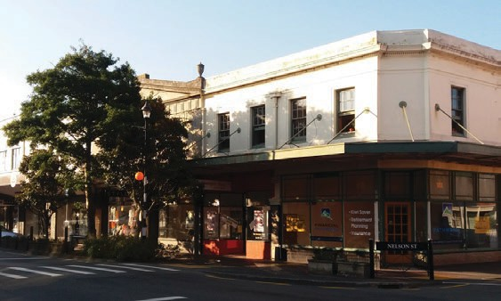

10

Designed by a prolific New Zealand architect
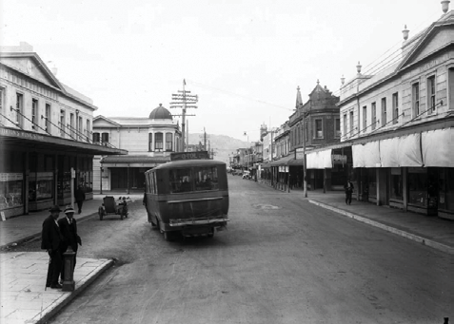

135–141 Jackson Street in 1929 (front left): looking down Jackson Street, Petone, with Stirton’s Music Store and the Alexandra Building in the foreground. Ref: 1/2-049106-G. Alexander Turnbull Library, Wellington, New Zealand.

Constructed in 1926, the two neighbouring buildings were designed by prominent Wellington architect William Gray Young. He designed over 500 buildings during his career, including Wellington and Christchurch railway stations.

Geoff and Jenny were fortunate that three of the four shop fronts were almost original – providing a good base for restoring the buildings to their initial design. On the first floor, the original windows, parapets, cornices and finials also remained, but were in need of restoration and strengthening.
“These works are a significant upgrade to the current condition of the buildings. For us, restoring and reinforcing the heritage elements along Jackson and Nelson Streets was critical, guaranteeing the future of the unique heritage appeal of the Jackson Street Historic Area,” says Geoff.

New Zealand Heritage List entry – Heritage New Zealand website

Addressing structural weaknesses, designing alterations
Geoff and Jenny’s plan involved both strengthening and alteration work, so the services of a structural engineer and an architect were required.

They hired Don Thomson Consulting Engineers to identify the buildings’ critical structural weaknesses and develop a seismic strengthening solution.

The resulting upgrade solution includes:

- installing portal frames to address a lack of bracing
- installing a new roof diaphragm to increase rigidity and restrain the brick walls and parapets
- installing a concrete first floor to act as a diaphragm
- adding reinforced sprayed concrete walls to strengthen exterior brick walls
- installing steel strong backs to strengthen internal brick walls.

Architectural firm Harriot Melhuish O’Neill designed the alterations, ensuring the buildings will be upgraded to current building code and meet the requirements of tenants.

Heritage EQUIP Funded Projects 11

Assessing the impact on heritage
Assessing the impact of proposed works on a building’s heritage fabric is an important step in the planning process. Hutt City Council’s heritage advisor carried out an assessment of the upgrade plans as part of the resource consent.

“Our goal of restoring and repurposing the buildings was well-aligned with the principles of the Jackson Street Historic Area, and this initially made the process relatively easy. The consent conditions were also well-aligned with our intentions,” says Geoff.

“Unfortunately, an important historic building in Petone was demolished in 2017 and the public criticism that followed had an immediate impact on our project.”

“The Council and its advisors became adverse to any loss of perceived heritage value, which did make it more difficult to resolve the changes that inevitably arose as the detailed design for our project progressed.”

As the buildings are part of a listed historic area, Heritage New Zealand approval was also sought.

Heritage New Zealand supported the proposed works, saying the “key elements and aesthetics of the historic street are preserved” and the proposed additions were “intended to improve the functionality of the buildings and their long-term sustainability.”

By the end of 2017, the strengthening solution and refurbishment designs were finalised and a building consent application was submitted to the Council.

Heritage EQUIP Funded Projects

Keeping tenants informed
As well as dealing with a number of building professionals, Geoff and Jenny also had to consider their tenants.

“It was vital to keep our tenants well-informed and give sufficient notice to vacate the buildings in order for the work to start. Leases had been monthly for many years, but we gave tenants six months’ notice, reviewing the date monthly as delays occurred. As tenants vacated, we were able to complete preliminary work, such as removing floor and wall linings to test existing foundation capacity,” says Geoff.

The end is in sight
After several years of planning, and securing a $100,000 grant from Heritage EQUIP, Geoff and Jenny are delighted to have their project underway and well on the road to completion.

Preliminary works, strip-out and ground stabilisation have now been completed, with the foundations and ground floor portals ready to be installed.

“Not only are the works going to ensure public safety, the renovated retail spaces should attract more retailers and shoppers to Petone. The
renovation of the apartments on the first floor and the addition of garages will also mean we can offer good quality, attractive accommodation in a central location,” says Jenny.

12

CANTERBURY

Hurunui Hotel, Hawarden
Owning one of the oldest hotels in New Zealand is a responsibility not taken lightly by Rodger and Nola Strong. The two-storey limestone building has been seismically strengthened, ensuring it will remain a local landmark for years to come.
The earthquake-prone historic Hurunui Hotel was damaged in the 2016
Hurunui/Kaikōura earthquakes and closed shortly after.

Thanks to the work of heritage specialists, and Rodger’s knowledge of heritage buildings as a retired builder, a seismic strengthening solution was developed to protect and strengthen the building’s precious heritage elements.

A 19th century country hotel

Structural engineer: Win Clark Building contractor: Rodger Strong Architect: Dave Pearson Architects (DPA Architects Ltd)
Stonemason: Pinnacle Stonemasonry
Date funded: March 2018

Seismic works budget: $350,000
Co-funding: Heritage New Zealand Project duration: 8 months (November 2017 to June 2018)
Building owner: Nola and Rodger Strong
Built in 1868, the Hurunui Hotel holds one of the oldest operating licences in New Zealand. The Category 1 historic place is constructed from layers of local hand-hewn limestone blocks packed with a mixture of tussock, clay and lime.

The hotel was built as part of a chain of accommodation houses for travellers on the main route between Canterbury, Nelson and the West Coast.

New Zealand Heritage List entry – Heritage New Zealand website

Getting expert help and funding advice
“We wanted to repair the building, but financially things didn’t stack up. We were feeling frustrated and uncertain about hotel’s future. We needed expert help,” says Rodger.

The local council were keen to see the 150-year-old building restored and put the Strongs in touch with engineer Win Clark and architect Dave Pearson.

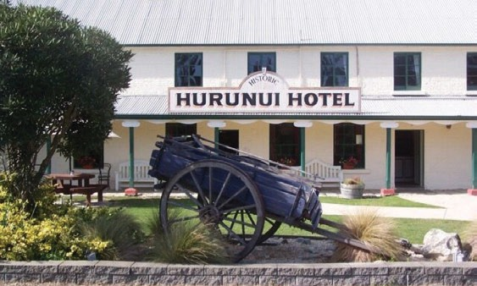

13

The pair, both with significant experience upgrading heritage buildings,
considered a number of strengthening solutions.

At the same time, Mike Frew from Heritage EQUIP had been in touch to discuss potential funding options.

“We weren’t aware of the funding available for privately owned heritage buildings,” says Rodger.

From there, engineering investigations and funding applications began.

A $16,000 grant from Heritage New Zealand’s National Heritage Preservation Incentive Fund enabled Rodger and Nola to get engineering advice.

A further grant of $132,503 from Heritage EQUIP was secured to help fund the strengthening work.

Developing a structural scheme to protect the heritage fabric
A detailed engineering evaluation (DEE) had been completed in 2013, and an assessment of earthquake damage and cost estimates for remedial work completed in February 2017.

Win and Dave used this documentation to develop a detailed plan for seismic strengthening.

Their plans addressed the hotel’s critical structural weaknesses – unreinforced stone masonry walls and gable ends.
“A number of strengthening solutions were considered, but the option we selected enhanced the capacity of the existing fabric to withstand earthquake effects, without adding significant new structure, thus protecting the building’s heritage appeal. This option also meant locally available materials and skills could be utilised,” says engineer Win Clark.

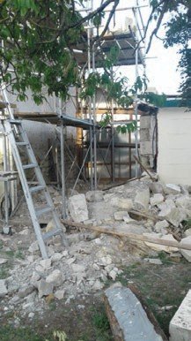
The strengthening scheme included:

Hurunui Hotel exterior with strengthening works underway

- tying the first floor into the perimeter
masonry walls
- installing a plywood diaphragm at
the first floor
- fixing the timber top plate to the top
of the masonry walls
- repairing and fixing the east and west
gable ends
- installing masonry ties to tie the inner and outer wythes together
- installing masonry ties to tie each
corner back into the body of the masonry walls
- installing masonry ties to stitch cracking in the outer wythe of the masonry walls
- fixing the four southern gables into the exiting roof framing

In reviewing the Strong’s funding application, the Heritage EQUIP panel praised the upgrade solution for being ‘sympathetic to the heritage values of the hotel.’

Heritage EQUIP Funded Projects 14

Community support for a local landmark
In a letter supporting their funding application, Mayor Winton Dalley stated the building was ‘a significant and prominent landmark’ for the region, ‘much admired and used’ by visitors and locals, and that ‘holds a special place in the history of the district.’

With work now completed, the Strong’s are planning to retire and either lease or sell the hotel. Whatever its future, the couple feel optimistic about the building’s future.

“We’re looking forward to seeing the hotel re-open, and once again providing a meeting place for both locals and visitors to Hurunui,” says Nola.

Top tips for other building owners
Rodger and Nola offer the following advice to building owners in a similar situation:

- Source as much information as you can about your building – especially about its structure and heritage value.
- There are lots of people out there who can help you. Talk to your local council to see what assistance they can provide. Do they offer funding? Can they put you in touch with heritage building experts?

Heritage EQUIP Funded Projects 15

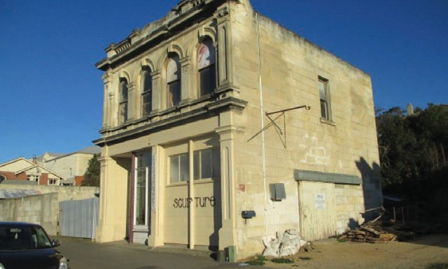
OTAGO/SOUTHLAND

Marshall Building, Oamaru
When Katrina Menzies purchased the Marshall Building, she knew there was a lot of work to be done. Thanks to her determination and careful planning, this vacant and badly deteriorated building will receive a much needed makeover.
Structural engineer: G.R. Littler
Building contractor: Breen Construction Company Architect: Draftline Limited Stonemason: Dooley’s Masonry Project budget: $350,000, with
$101,000 allocated for strengthening
works
Date funded: March 2018
Project duration: 6 months

Finding a restoration project
Looking for a new project, Katrina was keen on the idea of restoring a building. She had managed earthquake strengthening and renovations for her own home in Christchurch, and felt confident with the building process.

“Oamaru had always appealed, and when the Marshall Building came up for sale I knew we had to see it,” says Katrina.

The Marshall Building on Tees Street was originally used as retail space. But with limited foot traffic and low commercial rent in the area, Katrina had to think carefully about the viability of restoring the building to its original use.

After identifying high occupancy rates in Oamaru, Katrina decided that a change in use to tourist accommodation would be the best decision for the long-term viability of the building.

An Oamaru stone building with historical value
Built in 1880, the two-storey Marshall Building was designed by Forrester and Lemon, a prominent architectural firm responsible for designed several buildings in the area.

Tees Street and nearby Wansbeck Streets were the early commercial centre
of Oamaru, being close to the port and to Oamaru’s first railway station.

Constructed from unreinforced Oamaru stone with a timber framed roof and floors, the building features an ornate façade with round headed windows, pilasters, balustrades and a curved pediment.

16

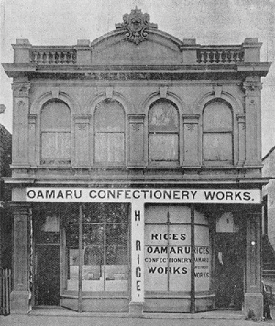
Although the majority of the building remained in its original state, parts of the parapet had been removed for pedestrian safety and the remaining parapet and the façade had badly deteriorated.

Photo courtesy of Waitaki District Archives.

New Building Standard (NBS)
%NBS refers to percent of the new building standard. It’s a rating of the expected seismic performance of an existing building relative to the requirements that would apply to a new building on the same site.

Developing an upgrade solution
She hired Gary Littler, a structural engineer, to carry out an initial seismic assessment (ISA). He found the building to be 15% NBS, classifying
it as earthquake-prone. When it came to sourcing building professionals, Katrina asked around for
recommendations, preferring to choose people with a proven track record.

Gary, with input from engineer Garth Green and stonemason John Dooley, proposed a strengthening solution for the building. They recommended inserting steel portal frames in the front wall, tying the building together with roof and floor diaphragms, and strengthening the parapet and façade corners with reinforced concrete beams and steel rods.

While strengthening to 34% NBS would mean the building was no longer earthquake-prone, the engineers recommended strengthening to 67% NBS. The project involved a major refurbishment, with minimal difference in cost to achieve 34% and 67%. Strengthening to 67% also put the building in a better long-term position.

Resource consent and unexpected requirements
After realising that getting a professional to complete the required resource consent application was beyond her budget, Katrina got stuck in carefully compiling her own.

It was then she found out about an expense she hadn’t budgeted – her project involved a pre-1900 building site, activating the need for an archaeological authority.

“It was a very steep learning curve,” admits Katrina.

Archaeological sites
Archaeological sites are defined as any place associated with pre- 1900 human activity, where there is evidence relating to the history of NZ that can be investigated using archaeological methods.

Heritage New Zealand regulate the modification of archaeological sites. If your work affects an archaeological site you must get an authority from Heritage New Zealand before you begin.

Heritage EQUIP Funded Projects 17

A budget blow-out leads to funding investigation
A carefully considered budget was “blown out of the water” once engineering and archaeological advice came in. Katrina realised she’d need financial help to get the project completed.

She went online, searching for as many potential sources of funding and assistance as possible.

“I realised really quickly that I wasn’t eligible for any of them because I have a privately owned building,” says Katrina.

It was at this time that she first came across Heritage EQUIP. While initially her unlisted building didn’t meet the criteria, things changed once it was included in an expansion of the Heritage New Zealand listed Oamaru Historic Area. Heritage New Zealand were supportive and encouraged Katrina to pursue Heritage EQUIP funding.

Katrina pulled out all the stops to make sure her application was a strong as possible, even hiring a cherry picker to take photos on the building elements with a low NBS. The photos also helped the stonemasons plan their upgrade work.

The investment paid off and Katrina was thrilled to be awarded $48,000 towards the strengthening work.

The value of community support
“I’m lucky that a lot of people in Oamaru are passionate about heritage buildings, and a lot of people bent over backwards to help,” says Katrina.

Heritage EQUIP Funded Projects
In a letter of support for Katrina’s Heritage EQUIP funding application, the Waitaki District Council said they were “pleased to see adaptive reuse of heritage buildings, with old buildings brought back to life through new uses.”

And the Oamaru Whitestone Civic Trust supported her application, saying “the best way for heritage buildings to be protected is to ensure their ongoing use.”

Adaptive reuse
Adaptive reuse refers to changing the use of a building to something different from what it was originally designed or used for. The new use is often chosen to make the building more economically viable, or more suitable for contemporary user requirements.

Tips for other building owners
When asked what advice she’d give other building owners, Katrina had the following tips:

- Have a “game plan”. It’s a complex process so tackle one thing at a time and be methodical.
- The project is likely to cost more than you expect. Make sure you have a contingency fund – you’ll need it!
- Do your research and take time to build relationships. Find out who’s passionate about heritage restoration within your community. Get them engaged by taking them on the journey with you – invite them to visit the site and get them involved in the long-term picture.

18

- Curve balls happen. Engineers retire, costs increase and there may be unexpected building requirements. Take a pragmatic approach, tackle each challenge as it comes up.
- You can’t satisfy everybody. Listen as much as you can to the experts, and go for the best outcome for the building.

A positive outcome for Oamaru
With building work about to get underway, Katrina is feeling optimistic about the future of her building and its contribution to Oamaru.

“I hope the restoration of this building will set a benchmark for the rest of Tees Street, which is only just starting to be rejuvenated,” she says.

Heritage EQUIP Funded Projects 19

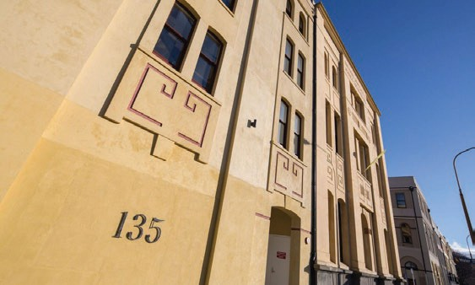
OTAGO/SOUTHLAND

Union Steam Ship Company’s

Offices and Stores, Dunedin
Once badly affected by rain damage and pigeon poo, a Dunedin landmark has been restored to glory.
The following article is courtesy of
Heritage New Zealand magazine (Issue 147 Summer 2017).
Words by Jamie Douglas.

The former Union Steam Ship Company’s Offices and Stores building in Dunedin was built to help ensure the safe passage and delivery of a range of goods and produce to the world.

Today, the 1883 building has been recognised with a Category 1 listing and is delivering a shipment of a much more valuable commodity – people – to Dunedin’s Warehouse District, bringing life back to a precinct that for many years had been left to languish.

In its heyday it was a magnificent sight, prominent in its maritime setting – the port just across the road – with entry from Water Street and wrapping around Cumberland and Vogel Streets. The original ornate, Italian architectural detail was modernised in the late 1940s to reflect a more streamlined Art Deco/Moderne style.

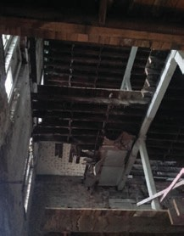
By then the National Mortgage and Agency Company had taken occupancy of the building, having swapped premises with the Union Steam Ship Company in 1921.

Inside the badly deteriorated building, before the upgrade works began. Photo courtesy of Dave Hanan.

The appearance may have changed over the years, and the building may now be divided into three separate titles, but its scale and presence still hold firm to this day, thanks in large part to its current owners.

The way the three owners have returned a degree of status and charm to the building is a credit to their drive, passion and vision.

20

Assistance was initially provided by the Dunedin City Council, with a
$20,000 grant in 2010 to help with the restoration of heritage features, while recognition of the outstanding transformation came in 2013 with the building declared the overall winner in Dunedin’s annual Heritage Re-use Awards.

Along the way it picked up the Barlow Justice Valuers/Heritage New Zealand Interiors Award for the Psychology Associates offices on the first floor.

Steve Macknight owns the grand corner building that is home to the psychologists, a wine company and an artist with gallery space. The top floor, which extends through to owner Dave Hanan’s building, is occupied by an electronics firm.

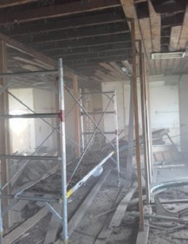
“It is great recognition for the building,” says Steve, of the recent Category 1 listing. “These buildings tend not to be recognised for what they are when they are seen in a rundown state. We knew the history of the place when we took

Inside the building, while the works were underway. Photo courtesy of Dave Hanan.
it over in 2010. People didn’t believe the original building was still around because the ornamental features had been changed [in the 1940s].

“It was in very poor condition. It had been empty for many years and we had a lot of problems with pigeons and rain water.

“I’m a structural engineer so can see where things are at. You really do
feel the history of the place when working on them. We had a good bunch of architects in Dunedin in the late 19th century. The foundations are reinforced concrete so these buildings were meant to be good, substantial buildings.”

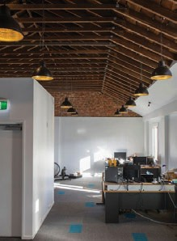
Dave Hanan’s entrance to his recently refurbished building is off Cumberland Street. In addition to the shared top floor, the building has been converted into five high-quality apartments, two of which are on Airbnb.

Office space after the upgrade project. Photo courtesy of Graham Warman.

He purchased it in December 2015 after taking Steve’s advice; the pair have known each other since their days at Logan Park High School. In a
unique twist, Dave also owns the property to which the Union Steam Ship Company shifted in the 1940s’ swap, having taken that on in 2009.

“Steve was a motivating factor behind buying the building, as it was in a very dilapidated state. The only redeeming features were its amazing views of the harbour and its cheap price,” recalls Dave.

“It’s certainly not a job for the faint-hearted. It’s bloody hard, and a challenging project financially. I’m very grateful for the support of Heritage New Zealand, the Heritage EQUIP fund, the Dunedin Heritage Fund and the Central City Heritage Buildings Re-use Grants Scheme. Without them chipping in, it wouldn’t have been viable.”

Heritage EQUIP Funded Projects 21

Dave’s building originally required a lot of vision to get past its “absolutely horrendous” condition. The Warehouse Precinct Revitalisation Plan put in motion by former Dunedin City Council Policy Planner Glen Hazelton was another key factor in seeing that potential realised.

“We’re very lucky in Dunedin that we didn’t have a period of huge population growth like Auckland, where a significant amount of heritage was lost. We still have massive heritage values here.”

Juan Gaspar was the first of the current owners to purchase his building eight years ago. As with the others, the condition left a lot to be desired, but owning construction firm Dunedin City Contracting certainly helped.

“It was boarded up and a metre deep in pigeon poo, and had flooded on three of the floors. It was a monumental effort to clean the place up and it’s quite an achievement to get this place to where it’s looking pretty good.”

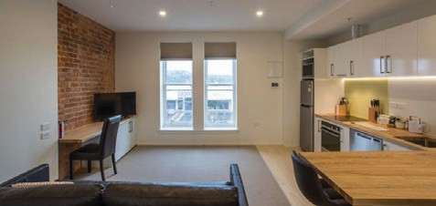

The former Union Steam Ship Company’s Store now provides modern apartments. Photo courtesy of Graham Warman.

Heritage EQUIP Funded Projects
Juan has a flooring wholesaler as a ground-floor tenant; his business Extreme Hobbies is on the first floor, and a comic shop and artist space are on the second floor. Heritage features include three large safes on each floor where mortgage documents were kept and an Otis lift that took six months to refurbish.

“You don’t take these buildings on unless you embrace the history and nostalgia of them. You have to really love them,” Juan says.

For Heritage New Zealand advisor Heather Bauchop, the Category 1 listing is entirely fitting. “Of all the buildings nationwide associated with the Union Steam Ship Company, Dunedin’s is the most outstandingly
significant and represents the company at the height of its economic power and influence.

“At its peak, the company was the largest shipping line in the Southern Hemisphere. Its architectural transformation in the 1940s added another rich chapter to the building’s history, and today the interior has been refreshed with 21st-century thinking.”

New Zealand Heritage List entry – Heritage New Zealand website

22

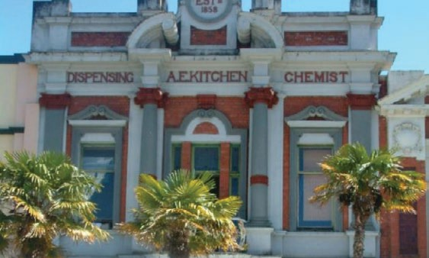
TARANAKI/WHANGANUI/MANAWATU

AE Kitchen building, Whanganui
When Kerry Girdwood began to painstakingly restore a jewel in Whanganui’s crown, she knew it needed significant seismic strengthening. After engineers carried out a detailed seismic assessment (DSA), Kerry decided to repair the structural problems using her own funds.
Structural engineer: EQSTRUC
Building contractor: DML Construction Limited Architect: Bruce Dickson Date funded: October 2017
Seismic works budget: $250,000
plus $47,100 for further strengthening of façade Project duration: 1 year

The final stage of the project was to strengthen the ornate façade. When scaffolding went up outside, Kerry got an unpleasant surprise. On closer inspection, the façade was more fragile than the DSA had revealed. Much more work was needed to bring it up to code – the budget for the façade had to be tripled.

Funding from Heritage EQUIP helped her complete the job.

Retail and residence from the beginning

The A E Kitchen building is a commercial building on Whanganui’s main street. Its Edwardian Baroque style makes it a feature of the city’s streetscape. Above the pharmacy was the Kitchen family’s home, which Kerry has restored to live in. Two shops now occupy the ground floor.

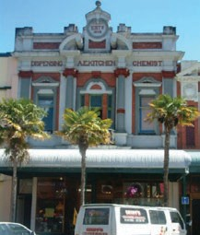
Designs for strengthening solutions

Photo courtesy of the Whanganui District Council Heritage Inventory. Register Item no: 395.
EQSTRUC completed a seismic assessment of the building for the previous owner in 2014, and drew up designs for a strengthening solution. Their DSA found the building earthquake prone with strengthening needed for the perimeter masonry walls and parapets, for the connections between the roof and walls, and for parts of the façade.

Kerry kept EQSTRUC on the project but asked them to go back to the drawing board.
23

‘The original design was intrusive and did not factor in the resilience of
native timber floors,’ she says.

While the seismic strengthening upstairs is unobtrusive, Kerry has left the steel supporting columns visible in the shops downstairs. ‘I want people to know the building has been strengthened,’ she says.

Heritage EQUIP funded further strengthening of the façade
The street-facing parapet and façade are particularly important to the heritage qualities of the building. They are the most decorative features and also the most visible.

Kerry says that one of the first floor pillars was noticeably leaning out.
‘It was probably loosened in the Kaikoura quake. The engineers put emergency strapping in immediately, then began permanent strengthening work.’

Kerry received Heritage EQUIP funding towards the extra cost. The grant was used to:

- tie the decorative façade columns to the façade
- tie the balustrade to the façade
- restrain the side parapet to the roof and tie it to the front parapet.

Whanganui’s oldest pharmacy was a landmark from the beginning
The Whanganui Regional Heritage Trust Board has described 15A Victoria Avenue as, ‘the most important frontage of all buildings in our central city’.

Heritage EQUIP Funded Projects
It is ‘in original condition, ornate, and beautiful,’ the board said.

When the pharmacy was built, the city was in the height of a building boom. The Wanganui Chronicle reported on 2 February 1909 that ‘During the last few days a large number of handsome business premises have been erected. Prominent among them is Mr A E Kitchen’s Pharmacy.’
No other building was mentioned – Kitchen’s was clearly already a local landmark.

The building is two storeys high – about 11 metres – and built from unreinforced brick masonry. The ground floor walls are three layers thick, and the upper floor walls two layers.

The Kitchen building was designed by architect T H James and built by Nicolas Meuli, both considered to be among the leading practitioners of their day.

Whanganui District Heritage Inventory listing – Whanganui District Council website

Many challenges to overcome
Kerry faced several big challenges during the strengthening and restoration project. Originally expected to take 4–6 months, it took just over a year.

Work on the seismic strengthening was delayed by several weeks. The consequences were expensive and frustrating. Much of the building work depended on the strengthening work, so the project nearly ground to a halt.

Kerry found the consent process for the seismic work straightforward. Getting consent for the restoration work was much more challenging.

24

When Kerry moved in, she was still working on compliance issues. If councils want to retain heritage buildings, she says, they must manage compliance without making it too difficult for owners.

Kerry found managing relationships between members of the project team to be difficult and costly. The first architect walked off the job. But her relationship with the second was comfortable.

The project exceeded its budget overall. Kerry upgraded the specifications
for the interior work and delays were expensive.

But she doesn’t regret doing the very best by the building.

Applying for a Heritage EQUIP grant was simple
When Kerry found out the extra cost of bringing the façade up to code, the district council’s town planner told her about the Heritage EQUIP fund.
Delighted, Kerry applied, and visited the team at the Ministry for Culture and Heritage in Wellington.

‘They were very good, very helpful and supportive. I was impressed.’ She says that after months of handling complicated paperwork, she appreciated a simple process and the clear application form and guidelines.

Top tips from a trailblazer
Kerry says she’s a trailblazer – one of the first private owners to seismically strengthen a heritage building under the new Building Act. She has learned a lot. ‘Come and talk to me. I could save you money!’ Here are her top tips:

Heritage EQUIP Funded Projects
- Be an information junkie – with more information you can make better decisions.
- Find out as much as possible about what the original building was like. Find out about alterations. As much as you can, avoid the ‘let’s take this wall out and see’ approach.
- Get a view from above. To avoid the cost of scaffolding, use a drone or a cherry picker to get aerial views.
- Take detailed photos at every stage to track the project. You may have to use them for insurance matters or disputes. And you have a very satisfying record of your hard work.

Inspiring other people who own historic buildings
The Whanganui District Council says the project is exactly what it envisaged in its Town Centre Regeneration Strategy. And the Whanganui Regional Heritage Trust Board says they want the project to inspire more building owners to invest in seismic strengthening.

‘Through projects like this, the trust hopes that Whanganui will gain a reputation as New Zealand’s best preserved heritage town,’ the trust said in its letter supporting Kerry’s application to Heritage EQUIP.

25

CANTERBURY

The Pumphouse, Christchurch
The Pumphouse buildings suffered in the 2011 Canterbury earthquakes. Rather than demolish the local landmark, owners Paddy and Jackie Snowdon are
strengthening the heritage buildings where they operate their demolition business.
The buildings are not only functional, they’ve caught the eye of many artists. A well-known painting of the buildings by Doris Lusk is displayed in Auckland Art Gallery, and the rambling relic has served as a backdrop for several wedding photos. With support from Heritage EQUIP, the buildings will continue to feature in modern day life.

Christchurch’s most important utility building
Paddy and Jackie Snowdon purchased the Pumphouse at 544 Tuam Street in 1989. Parts of the building date back to the early 1880s when it was built as the city’s original sewage pumping station. It operated as a pumping

Structural engineer: CGW Consulting Engineers
Building contractor: Higgs Construction Architect: Fulton Ross Team Architects Quantity surveyor: Harrisons Quantity Surveyors
Project budget: $1,280,000
Date funded: July 2017
Project duration: October 2017 to approximately March 2018
station until 1957.

An article about the buildings was written in Historic Places at the time it was sold to the Snowdons. It was described as Christchurch’s ‘most
important surviving early utility building’ and it was hoped that it would be put to some alternative use rather than be demolished.

The Snowdons did just that – ‘The Pumphouse’ has been the name of their demolition business for the past 28 years. ‘They are ideal buildings to house our demolition yard and fitting for our collection of architectural antiques,’ says Jackie.

The buildings were red-stickered after the 2011 earthquakes
The Pumphouse is made up of five attached buildings with deep foundations and thick, brick walls. The buildings’ robust construction saved them from destruction in the 2011 earthquakes, but they were rated as potentially dangerous to the public and red-stickered. Paddy and Jackie were forced to operate from temporary garages and shipping containers immediately after the earthquakes.

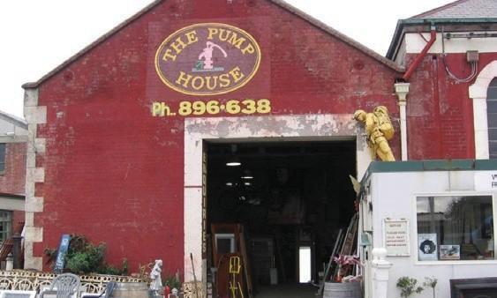
26

In 2014, after a few false starts, Paddy and Jackie found an engineering firm that ‘had the time and interest to work on strengthening plans for the buildings’. Engineers from CGW Consulting carried out a full investigation of the structure and found the strength of the complex of buildings to be 10% of the New Building Standard (NBS).

Planning the strengthening project
Paddy and Jackie thought it was worth spending money at the planning stage so they were able to make informed decisions. Engineers prepared plans to strengthen the buildings to 34% and 67% NBS and both plans were costed by a registered quantity surveyor.

“We decided we should strengthen to 67% NBS rather than 34% NBS to ensure that such historic buildings got maximum protection.”

The consent processes were straightforward for Paddy and Jackie. The Engineer worked through the building consent and advised the Snowdons to hire a consultant for the resource consent. The Council requested technical information so Paddy and Jackie quickly realised this was a job for the professionals.

Paddy and Jackie recognise the significant heritage value of the buildings
The Snowdon’s proposal for the strengthening work carefully considered the effect on the environment and the impact on the buildings’ heritage value. The site of the Pumphouse is a Category 2 historic place on the New Zealand Heritage List and scheduled on the Christchurch District Plan.
Paddy and Jackie have been granted a resource consent that includes conditions to protect the heritage value of the building.

Heritage EQUIP Funded Projects
New Zealand Heritage List entry – Heritage New Zealand website The Snowdons applied for Heritage EQUIP funding
Paddy and Jackie have been awarded $200,000 from Heritage EQUIP to contribute to the cost of:

- installing of roof diaphragms
- strengthening brickwork with steel rods
- improving connections between the roof, walls and floor
- installing brace framing

The Pumphouse buildings have high significance to Christchurch
The sewerage system of the Pumphouse was the ‘cornerstone of 19th century Christchurch’ that led to a significant improvement in residents’ quality of life.

The Christchurch Drainage Board was established in 1875-76 in response to the city-wide sewage and drainage problems. The unhygienic situation had dire consequences – water-borne diseases were a leading cause of the city’s high death rates.

Parliament at the time passed special legislation to come up with an engineering solution. The pumping station included an underground sewage tank and pumping engines to pump sewage along cast iron pipes out from the city centre.

Construction methods used for the pumping station are technologically significant. Engineers had to use innovation and skill to design a building that sits on sand and river sediment.

27

The Pumphouse buildings have architectural significance for their utilitarian design and technological craftsmanship. They are built from brick, with classical detailing using Oamaru stone.

“We are looking forward to getting our project underway. We think our buildings are really cool and have such a great link to Christchurch’s history – even although pumping sewerage wasn’t exactly a glamorous role!” says Jackie.

Challenges of the project
Paddy and Jackie were under pressure to find the funding needed to start the project before their building consent expired in August 2017. The structural engineers were also challenged by the fact that the property contains five connected buildings. They had to come up with strengthening solutions for each building and consider how the buildings would interact in an earthquake.

Paddy and Jackie hope that the strengthening work won’t disturb their demolition business. The work will be carried out in stages to allow them to keep their business going while the work is being done.

Future plans for the Pumphouse
The Snowdons plan to continue their demolition business on the site and also see huge potential for the buildings in the future. “The buildings would lend themselves for use as a workshop, a café or restaurant, or funky offices.”

Heritage EQUIP Funded Projects 28

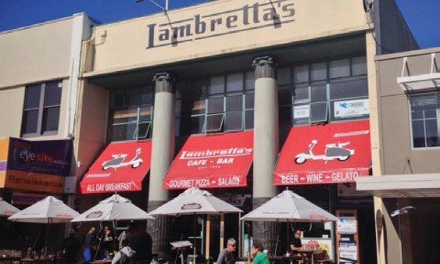
MARLBOROUGH/NELSON/TASMAN

204 Hardy Street, Nelson
The owners of this Nelson building took a staged approach to earthquake strengthening. This meant managing costs and keeping their tenant happy.
Structural engineer: AMK Limited
Building contractor: C Moore Construction
Date funded: June 2017

When Ben Van Dyke and Miranda Wood were notified by the Nelson City Council that their building at the heart of Nelson’s CBD was earthquake- prone, they had a costly decision to make. They had already spent
more than $60,000 on structural work of the historic building, and ‘guesstimated’ that further strengthening would cost nearly $130,000. The engineer’s estimate was higher still.

A mid-century commercial building
The building at 204 Hardy Street is known by locals as Lambretta’s, after the popular restaurant that operates on the ground floor. Customers enjoy Nelson’s long hours of sunshine under awnings beside the impressive columns. The mid-century commercial building is built from reinforced concrete with a ‘glass curtain wall’ façade. It was completed in 1956 for the New Zealand Insurance Company (NZI), who chose this façade design for their corporate image.

The building was assessed and rated earthquake prone
Early in 2017, engineers from AMK Limited carried out a detailed seismic assessment and found the strength of the two-story building to be 15% of the New Building Standard (NBS). The main areas of concern were the first floor columns and the parapets. These elements are the first to be
addressed in a seismic upgrade scheme that took the building to 70% NBS.

29

Heritage EQUIP funding has allowed Ben and Miranda to strengthen the building
Nelson City Council (NCC) sent a survey to all owners of Nelson heritage buildings, along with an application for Council funding to help with earthquake strengthening. Ben and Miranda had already been through a ‘bureaucratic obstacle course’ to strengthen the building in the past, so were hesitant to apply for funding.

The turning point came for the couple when Richard Frizzell from NCC connected them with Mike Frew from the Ministry for Culture and Heritage. NCC supported Ben and Miranda’s application for Heritage EQUIP funding. Miranda says Richard was tremendously helpful and made the EQUIP funding application seem less daunting. “I was pleasantly surprised by how helpful everyone has been. Everyone bent over backwards to assist us. Mike was very encouraging and was ready with information whenever I called.”

Ben and Miranda chose to undertake the project in stages. In June 2017 they were awarded $94,700 from Heritage EQUIP for the first phase of the work. A year later Heritage EQUIP provided a further $80,000 for the next stage. Ben and Miranda also received a $10,000 grant from Nelson City Council. The strengthening work, which was only internal, didn’t affect the building’s heritage value and Lambretta’s continued to be part of Nelson’s cityscape.

A building of architectural and historical significance
The building has architectural significance because it showcases the work of notable New Zealand architectural firm Gummer & Ford and Nelson architect Alexander Bowman. Its association with NZI and a well-known local law firm, Fell & Harley (who owned the building from 1982 to 1991),

Heritage EQUIP Funded Projects
makes it of historical importance too. The building is a Category 2 historic place on the Heritage New Zealand List, and a Heritage Category C in the council’s district plan.

“We have lost many heritage buildings in this area and those remaining need to be cherished and strengthened for the enjoyment of future generations,” says Miranda.

Strengthening work has begun upstairs
The building was strengthened in two stages – the first stage was part funded by Heritage EQUIP and aimed to achieve at least 34% NBS, while completion of the second stage saw the building achieve 70% NBS. Breaking the work into two made it less of a strain financially, and less disruptive for the restaurant.

Stage one strengthening work involved:

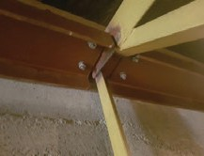
- tying the concrete parapets to the structural steel in the roof

New steel cross bracing added to the roof space. Photo courtesy of Miranda Wood.
- strengthening the concrete columns using retrofitted steel wall cross bracing
- strengthening the double brick infill wall above first-floor level.

Stage two strengthening work involved:

- strengthening the double brick infill wall below first-floor level
- installing new structural steel frames and concrete shear walls.

30

Strengthening an earthquake-prone building can be challenging
Ben and Miranda have encountered a number of challenges along the way, including finding professionals, securing funding, and working around the peak times at the restaurant. Until they hired an engineer, they had no way of knowing how big the job would be, what was involved or how much it would cost. The first engineers that worked on the project were slow to provide a quote and were costly in terms of time and money.=

It was a frustrating time for Ben and Miranda, but they say it’s definitely worth waiting to have the best engineers work on your heritage building. They recommend speaking to others who have gone through the process, and to Heritage EQUIP. “Shop around for a good and honest structural engineer. If things go to custard, sack them,” says Ben.

All structural engineers are pretty busy because thousands of buildings need this type of work. It took their new engineers at AMK Ltd some time to return the report for the funding application. Miranda says the application process made them focus on the project and forced them to think about
the steps involved, which pulled things together. “Now, with the substantial funding assistance from EQUIP and the $10,000 from Nelson City Council’s Heritage Project Fund, we have at last started work.”

The first stage of the project was completed by September. Work on the ground floor was more difficult as it could only be done when the restaurant was closed. Ben and Miranda carried out the work in stages during winter, when the restaurant was not as busy, to minimise the impact on the tenant.

Heritage EQUIP Funded Projects

Ben and Miranda have plans for the building’s future
The upstairs space has been vacant since the building was deemed earthquake prone. Ben and Miranda hope to be able to rent the upstairs to a commercial tenant now the strengthening work has been completed. “We had interest from an individual who wanted to open an art gallery – this would be a perfect match for the light-filled space. It’s also well suited to offices or community-based organisations. Being located in the heart of Nelson’s CBD adds to 204 Hardy Street’s attraction,” says Miranda.

Ben and Miranda have only been able to carry out this project as a result of the grant from Heritage EQUIP. “I wish we’d talked to the Ministry
for Culture and Heritage sooner. They provided us with good advice and encouragement, and smoothed the way for us.”

31

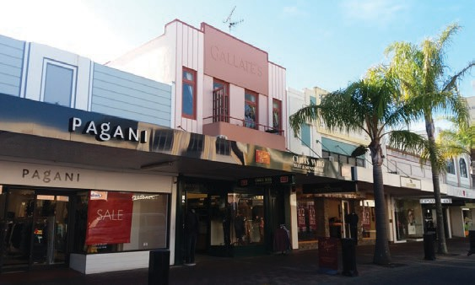
GISBORNE/HAWKE’S BAY

Gallate’s Building, Napier
When the owners had confirmation that their art deco building was earthquake-prone, they were keen to find a simple, low-cost solution that wouldn’t disrupt their tenants.
Structural engineer: Design Phase
Limited
Building contractor: GR8 Construction
Date funded: July 2017
Seismic works budget: Approx
$35,000
Seismic strength addressed:
Unreinforced brick side walls

Assessment finds the building is earthquake- prone
Following a request from the local council to confirm whether or not the building was earthquake prone, the owners of the Gallate’s Building commissioned an engineer to undertake a detailed seismic assessment.
The assessment found the building was rated at 15% NBS, confirming its
earthquake-prone status.

Getting expert advice and engineering solutions
The owners, JBR Nominees Ltd, were keen to ensure the safety and continued tenancy of their building so decided to proceed with strengthening.

To better understand their options, the owners asked Design Phase engineers to peer review the original seismic assessment. Design Phase completed further onsite investigations and provided new information about building materials used and connections between structural elements. The engineers proposed a seismic solution and costs to strengthen the upper floor walls using steel braces with spliced connections.

Part of Napier’s iconic art deco streetscape
Gallate’s Building was built in 1932 following the Hawke’s Bay earthquake. The two-storey building was designed by JA Louis Hay in the art deco style prevalent at that time. It was built by Holder Bros and constructed from brick and reinforced concrete.

Originally used as the offices and store for Woollen Distributors Ltd, today

32

a menswear retailer operates from the ground floor and the second floor is
an apartment.

Gallate’s Building is a Group 1 heritage item on the Napier District Plan – an acknowledgement of the building’s heritage value and contribution to Napier’s iconic streetscape. The building is also included on the New Zealand Heritage List as part of the Napier City Centre Historic Area.

Due to the heritage values of the building, work was limited to the interior of the building so no disruption of the art deco façade was needed. Plans included make-good of wall linings once the steel bracing had been installed.

Napier City Council and Heritage New Zealand were both involved in reviewing the proposed work and supported the strengthening methods as being sensitive to the heritage values of the building.

Financing the work
When JBR Nominees Ltd put together a budget for their project they needed to allow for a range of expenses. These included:

- project management and consultation costs
- engineering assessments, design solutions and costings
- building consent fees
- construction costs, including labour and onsite project management
- costs of materials
- costs of relocating tenants while the work is undertaken
- a contingency sum for unexpected expenses.

The project was awarded a $14,753 grant from Heritage EQUIP.
Heritage EQUIP Funded Projects 33

GISBORNE/HAWKE’S BAY

Mid City Plaza, Napier
A major seismic strengthening project has given this piece of Napier heritage a new lease on life.

Engineering assessment finds unexpected construction materials
Mid City Plaza is a collection of interconnected buildings located between Emerson Street and Dickens Street in Napier. The buildings were constructed between 1920 and 1933 and have undergone various alterations.

Structural engineer: ISPS Consulting
Engineers NZ Ltd
Building contractor: Arrow
International
Architect: Dougan Larkworthy Team
Architects

Date funded: June 2017
Seismic strength addressed: Foundations, floor diaphragms, out- of-plane wall strength
The two story building on Dickens Street was designed by local architect EA Williams for the Hawke’s Bay Farmers Co-operative Association. It was built in the early 1920’s and survived the 1931 Napier earthquake.

An initial seismic evaluation was conducted in 2013 and a detailed structural analysis conducted in 2014. These assessments determined the Dickens Street building to be below 34% of the new building standard (NBS) and therefore earthquake-prone.

In 2017, engineering company ISPS Consulting Engineers were commissioned to design potential seismic strengthening solutions. Investigation of the building turned up some unexpected building materials. The first floor concrete slab was found to have been constructed without reinforcing: the ‘waffle’ slab floor (with voids formed by empty tin cans to reduce weight) was not uncommon in buildings of this age.

Strengthening solution proposed
The Dicken’s street building consists of reinforced concrete columns and beams. The side and rear elevations are a plain plaster finish over concrete. The original façade has been altered since the 1920’s with the addition of a veranda and alterations to the original steel framed windows.

ISPS Consulting Engineers provided designs for seismic strengthening to

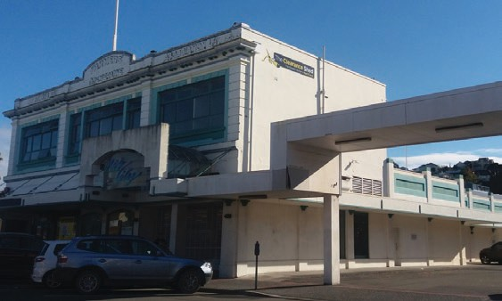
34

70%NBS. These recommendations included:

- removing the unreinforced concrete first floor structure and replacing it with a new timber framed floor with a plywood diaphragm
- adding bracing at the first floor level
- building shear walls on the ground floor with new foundations tying in
the existing walls and columns

Investigating the building’s heritage fabric
The buildings historical value is recognised through its listing as a Group 1 heritage item on the Napier District Plan and its inclusion on the New Zealand Heritage List as part of the Napier City Centre Historic Area.

As a heritage listed building, the work needed to take into account the building’s heritage fabric. A heritage assessment had been undertaken in 2013, and the interior of the building was reviewed with the Napier City Council when applying for project resource consent in 2016.

The most significant heritage fabric was found to be the exterior street facing façade. Fortunately, the proposed seismic strengthening works were all internal and didn’t impact the façade.

Funding the project
The upgrade project was awarded a $150,000 grant from Heritage EQUIP. This contributed towards the costs of removing the unreinforced first floor and replacing with a timber diaphragm structure, steel bracing on the first
floor and constructing ground floor foundations and shear walls.

A positive future
The strengthening work ensures the Dickens Street building will be retained as an important contributor to Napier’s central city historic area. The building upgrade also helps ensure ongoing commercial viability of the building.

Heritage EQUIP Funded Projects 35

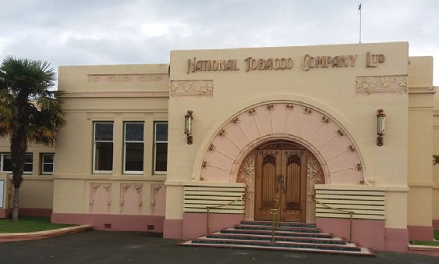
GISBORNE/HAWKE’S BAY

The National Tobacco Company Building, Napier
This iconic industrial building in Napier was one of the
first to be awarded funding from Heritage EQUIP.
Structural engineer: Structural
Concepts Limited
Building contractor: Your Solutions Limited
Date funded: May 2017
Seismic works budget: $30,000 (a
small part of wider works) Seismic strength addressed: Unreinforced masonry parapets

Assessing the building’s seismic strength
In October 2016 Structural Concepts Limited, a Napier based structural engineering firm, were engaged to undertake a detailed seismic assessment (DSA) of the National Tobacco Company building.

Structural Concepts found the building had been designed in a robust manner, with good structural redundancy, on solid foundations and floors. They determined the strength of the building to be 15% of the New Building Standard (NBS), making it earthquake-prone.

The low NBS rating was due to weakness of the parapet above the art deco main pedestrian entrance. Strengthening the parapet was expected to bring the building’s NBS up to 67%NBS.

When the building owners were told the parapet was earthquake-prone, they decided to close the art deco foyer to the public until strengthening works were completed.

A local icon and tourist attraction
The National Tobacco Company building is a place of local, regional and national significance due to its association with the social and economic history of Napier. The building was constructed for Gerhard Husheer as a tobacco processing factory. Husheer’s National Tobacco Company was the largest employer of locals in the 1930s.

The building was designed by Louis Hay, a well-known and highly regarded Napier architect. Hay also designed the art deco entrance, which was built after the original structure was damaged in the 1931 Hawke’s Bay earthquake. The imposing entrance has become a major tourist attraction, and a popular stop for Napier’s art deco tours.

36

The building’s heritage value is recognised in its listing as a Category 1 historic place on the New Zealand Heritage List.

New Zealand Heritage List entry – Heritage New Zealand website Find out more about the building’s history – NZ History website

Adapting the building’s use
The building had been underutilised for some time so seismic strengthening work was completed along with a major refurbishment and alterations to the internal layout to accommodate new tenants. A new brewery and an urban winery feature in the tenant mix. Both have been drawn to the sensitive upgrade of the building’s significant architectural features.
In recognition of the heritage value of the building, the project was awarded a $10,000 grant from Heritage EQUIP. The grant contributed towards the costs of tying back the brick parapet to the roof.

With a tenant secured and strengthening work completed, the National Tobacco Company building will continue to play an important part in Napier’s economy.

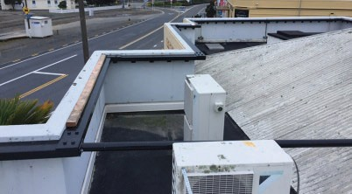

Tying the brick parapet to the roof. Photo courtesy of Napier BSL No1 Limited.

Heritage EQUIP Funded Projects 37

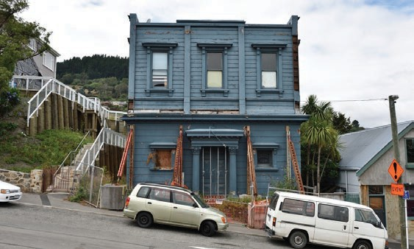
CANTERBURY

Kilwinning Lodge, Lyttelton
Brighter future for a ‘portal to the past’
Structural engineer: Structex
Architect: Fulton Ross Team Architects
Date funded: July 2019
Building owner: Kilwinning Limited

From Masonic Lodge to art studio
The Canterbury Kilwinning Lodge is a familiar landmark in the heart of Lyttelton. Completed in 1881 as a single-storey brick building, it was to be the location of the Freemason meetings for the next 119 years. In 1903, a massive fire gutted the building. Rather than demolish and rebuild, the
building was reinstated using the existing brick walls and facade. A timber second storey was added at this time.

A slow decline in membership of the Lodge led to the closure and the sale of the building in 2000. It was then repurposed as the art studio and residence of celebrated New Zealand artist Bill Hammond. The building
suffered significant damage in the 2011 Christchurch earthquake, and was declared unsafe and left vacant. Although insurance paid for the internal and external bracing, the building’s future was in serious doubt.

Massive restoration celebrates masonic features
Will Lomax, Don Mackay and Adam Walker have a bold vision for Kilwinning Lodge. They purchased it in December 2015 and, with their ambitious plan for the building’s future, demolition was averted. When completed, the upper level will be utilised as the office of their structural engineering company Structex, and the lower level will be leased to retail or hospitality tenants.

There’s a big task ahead but they have plenty to work with. While the exterior is handsome, its interior is unexpected. Numerous masonic features still evident in the architecture and décor, particularly in the upstairs space which Lomax has described as ‘a portal to the past’. An internal peephole, a high lantern ceiling, a secret hidden room, tiled floor and ornate timber staircase together give the interior of the building unique charm. Many of these features will be incorporated into the

38

strengthening project.

The works required are extensive. The majority of the design work has been undertaken by Fulton Ross Team Architects and the owners’ structural engineering firm, Structex. Their plan includes adding a mezzanine to the upper floor, removing and replacing of the damaged unreinforced masonry walls, the adding steel framing, and retaining,
repairing and reconnecting the façade. The bottom floor will be kept but
will need extensive work.

Multiple heritage funding sources
To make their vision a reality, the building owners secured a grant of
$150,000 from Heritage EQUIP in addition to a Christchurch City Council Heritage Incentive Grant.

Contributing to the community
Lomax sees the project as not just an architectural and structural engineering challenge, but a way to do something positive for the Lyttelton community, which had a number of significant buildings either damaged or completely lost due to the the Canterbury earthquakes. The building will continue to contribute to the streetscape of the Heritage New Zealand Pouhere Taonga Lyttelton Historic Area.

Heritage EQUIP Funded Projects 39

Other funded projects
Information relating to projects that Heritage EQUIP funding was awarded to between 2017 and 2020.

Eight buildings in Whanganui

Grant: $154,003
Grant Type: Professional Advice Grant
Date funded: May 2020
Whanganui is well-regarded (nationally and now internationally, as a member of the League of Historic Cities) for its stock of late-Victorian and Edwardian buildings, particularly concentrated in the city centre. The multiple buildings that are part of this advice are amongst the most crucial of these
– both as individual structures and as contributors to the central streetscape.

Whanganui’s Town Centre Regeneration Strategy highlights the CBD’s heritage stock as a priority for strengthening to enable adaptive reuse, and eventual introduction of up-to-code apartments in the upper storeys of central heritage buildings.

On behalf of building owners, the Whanganui District Council put together a Heritage EQUIP multiple building application to part-fund professional advice based on fee proposals from several engineering firms.

The Heritage EQUIP professional advice grant will go towards a detailed seismic assessment, concept structural design, and high-level costing
of that design for each of the eight buildings. Three engineering firms will undertake the advice across the eight buildings.
This outcome is the result of successful partnership work between the building owners, Whanganui District Council, Heritage New Zealand, and Heritage EQUIP.

All buildings are listed as heritage items in the Whanganui District Plan, and 30 Drews Ave is listed with Heritage New Zealand as a category 2 historic place.

New Zealand Heritage List entry for 30 Drews Ave – Heritage New Zealand

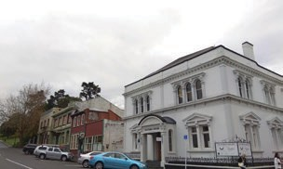
Heritage EQUIP Funded Projects 41

255 Cuba Street, Wellington

Grant: $50,000
Grant Type: Upgrade Works Grant
Date funded: May 2020

Built in 1935, 255 Cuba Street is a fine example of the work of architectural firm Dawson and King. Comprised of four apartments and three retail units, the building was designed in an Art Deco style with the standout features being the wrought iron balconies and parapet.

The Heritage EQUIP upgrade works grant will go towards installing brace framing on new foundations to span all floors, along with installing steel corner posts to the ground and first floors.

Located within the Cuba Street Historic Area, 255 Cuba Street is a Heritage New Zealand listed Category 2 building.

Heritage New Zealand entry – Heritage New Zealand website

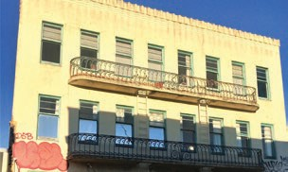

Heritage EQUIP Funded Projects 42

129 High Street, Christchurch

Grant: $150,000
Grant Type: Upgrade Works Grant
Date funded: May 2020

129 High Street was built in 1927 to a design by Samuel and Alfred Luttrell in a restrained At Deco moderne style with simplified classical features. For many years a BNZ, and then a video rental premises, and situated on a prominent corner, the building acts as a bookend for an important heritage precinct in Christchurch’s CBD.

The building has been unoccupied since the earthquakes and sits on the infamous Christchurch ‘dirty 30’ list. The upgrade will provide for commercial space on the ground floor, an apartment on the first floor, and a second apartment in a new upper floor to be added.

The Heritage EQUIP upgrade works grant will go towards:

- Fibre reinforcing to existing unreinforced masonry walls and existing concrete portal frames
- A new ground floor bracing frame on strengthened
foundations
- New concrete flooring/foundation slab to the ground floor
- Parapet bracing.

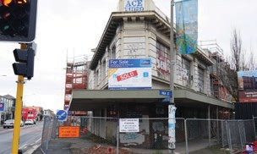

Heritage EQUIP Funded Projects 43

201 Dee Street, Invercargill

Grant: $20,000
Grant Type: Upgrade Works Grant
Date funded: May 2020

201 Dee Street was built in 1926 in a simplified art deco design. The building is located opposite the historic St Paul’s Church in Timaru and is scheduled as a heritage item in the Timaru District Plan.

A detailed seismic assessment was undertaken in 2018 and identified the critical structural weaknesses as the reinforced concrete walls, columns and the first floor diaphragm.

The Heritage EQUIP upgrade works grant will go towards installing four internal structural steel portal frames.

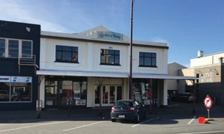

Heritage EQUIP Funded Projects 44

Pascoe’s Buildings, Hamilton

Grant: $150,000
Grant Type: Upgrade Works Grant
Date funded: May 2020

The Pascoe’s Buildings are located prominently on corner of Garden Place and Victoria Street. They were built in 1916 for Joseph Frear and formerly known as the Frear’s Buildings. Designed in the Free Classical style, the buildings were among the earliest substantial commercial buildings to be built in central Hamilton. One of the original retail tenants, jewellery firm of James Pascoe, bought the buildings from the Frear family in 1928 – later they were renamed the Pascoe’s Buildings.

A detailed seismic assessment identified unreinforced masonry walls, parapet, chimneys and roof bracing as the building’s critical structural weaknesses.

The Heritage EQUIP upgrade works grant will go towards installing portal frames, roof and canopy bracing, installing timber strongbacks to masonry walls, steel angle brackets to the underside of the first floor slab and parapet strengthening.

The Pascoe’s Buildings are listed with Heritage New Zealand as a category 2 historic place and scheduled as a heritage item in the Hamilton District Plan.

Heritage New Zealand entry – Heritage New Zealand website

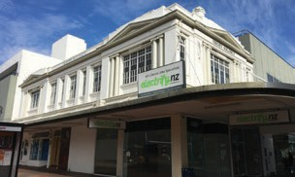

Heritage EQUIP Funded Projects 45

Administrator House

Grant: $150,000
Grant Type: Upgrade Works Grant
Date funded: May 2020

Built in 1925 for Alliance Assurance, Administrator House has a distinctive Classical facade of Oamaru limestone and Nelson marble. It’s much admired and significant elevation makes it an important feature of the O’Connell streetscape in the heart of Auckland’s CBD.

A detailed seismic assessment identified the critical structural weaknesses to be the limestone veneer and pillars, parapets, front and rear elevations, and the ground floor internal masonry walls.

The Heritage EQUIP upgrade works grant will go towards installing a new braced frame and connections, improving diaphragm connections,
strengthening the parapets, and connecting street façade elements back to the main structure.

Administrator House is scheduled as a heritage item in the Auckland District Unitary Plan.

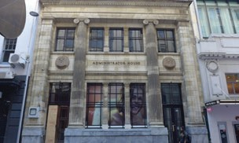

Heritage EQUIP Funded Projects 46

280 Hardy Street, Nelson

Grant: $30,000
Grant Type: Upgrade Works Grant
Date funded: May 2020

Built in 1860, and currently home to the Sprig and Fern Tavern, 280 Hardy Street is scheduled as a heritage item in the Nelson District plan. The building has undergone strengthening in 1994 and some alterations in 2004. An initial seismic
assessment in 2016 rated the building as 10%NBS.

The Heritage EQUIP upgrade works grant will go towards establishing ground floor structural steel portal frames at the street frontage, installing strap bracing to the underside of the footpath veranda joists, and installing brace lining to the front bar area.

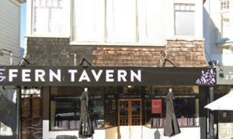

Heritage EQUIP Funded Projects 47

Johnston and Co. Building, Whanganui

Grant: $220,000
Grant Type: Upgrade Works Grant
Date funded: May 2020

Constructed in 1914, the Johnston & Co. Building is a three story Edwardian Baroque building historically associated with mercantile activity. It has a prominent location in central Whanganui, alongside the river and adjacent to the main bridge into town.

The owner undertook a detailed seismic assessment
which identified the structural weaknesses to be the unreinforced masonry parapets, top storey perimeter walls, front and rear facades, and floor and roof diaphragms.

The Heritage EQUIP upgrade works grant will go towards parapet bracing and rear parapet height reduction, top storey strongbacks, installation
of shear wall and floor diaphragms with robust
connections and cross bracing.

The Johnston & Co. Building is scheduled as a
heritage item in the Whanganui District Plan.

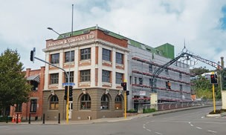

Heritage EQUIP Funded Projects 48

Star and Garter Stables, Oamaru

Grant: $80,000
Grant Type: Upgrade Works Grant
Date funded: May 2020

Perhaps Oamaru’s earliest surviving building, this stone outbuilding is sited behind the former Star and Garter Hotel. It is known as the ‘Men’s Hotel’ or the ‘Bullock Drivers’ House’ and provided stabling and perhaps a place to stay for bullockys and wagoners in the early 1860s. It was later converted to a private residence and has also served as a bakehouse, and an electrical workshop and store.

A recent detailed seismic assessment identified the critical structural weaknesses as the out of plane capacity of stone walls, and lack of diaphragm action restraining the upper floor and roof.

The Heritage EQUIP upgrade works grant will go towards the installation of plywood first floor and roof diaphragms, and steel frames on concrete foundations that tie the roof structure and walls. The building will be converted fto residential use at the same time.

The stables are listed by Heritage New Zealand as a Category 2 historic place.

Heritage New Zealand entry – Heritage New Zealand website

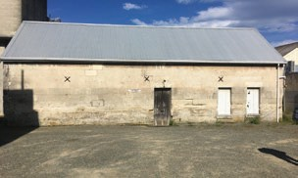

Heritage EQUIP Funded Projects 49

Wairoa Meat Co. Building, Wairoa (works)

Grant: $200,000
Grant Type: Upgrade Works Grant
Date funded: May 2020

The Wairoa Meat Co. building was originally built in stripped art deco style as a carriage workshop sometime between 1915 and 1920. Unlike many of the buildings around it, it survived the 1931 earthquake. It was repurposed as a Ford car show room and later as the local butcher.

The new owners of the building commissioned a detailed seismic assessment soon after purchase. It identified limited capacity of the concrete frame,
ceiling diaphragm, and roof frame. The owners plan to improve the commercial space on the ground floor, and residential accommodation upstairs.

A Heritage EQUIP professional advice grant in December 2019 went towards the cost of concept, preliminary, developed, and detailed structural design as well as a heritage impact assessment.

This Heritage EQUIP upgrade works grant will go towards the seismic strengthening that consists of front and rear concrete shear walls with associated foundation work, a steel roof bracing system, footpath canopy bracing, and concrete repair.

The building is listed as a Category 2 historic place with Heritage New Zealand.

Heritage New Zealand entry – Heritage New Zealand website

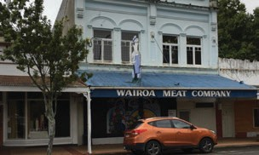

Heritage EQUIP Funded Projects 50

Wairoa Meat Co, Wairoa (advice)

Grant: $30,000
Grant Type: Professional Advice Grant
Date funded: December 2019

The Wairoa Meat Co. building was originally built in stripped art deco style as a carriage workshop sometime between 1915 and 1920. Unlike many of the buildings around it, it survived the 1931 earthquake. It was repurposed as a Ford car show room and later as the local butcher.

The new owners of the building have commissioned a detailed seismic assessment soon after purchase. It identified limited capacity of the concrete frame, ceiling diaphragm, and roof frame. The owners
plan to provide improved commercial space on the ground floor, with residential accommodation upstairs.

A Heritage EQUIP professional advice grant of
$30,000 will go towards the cost of a concept, preliminary, developed and detailed structural design and a heritage impact assessment.

Following this advice, in May 2020, a Heritage EQUIP upgrade works grant was awarded for the seismic strengthening based on the detailed structural design.

The building is listed as a Category 2 historic place with Heritage New Zealand.

Heritage New Zealand entry – Heritage New Zealand website

Heritage EQUIP Funded Projects 51

Devonport Flats, New Plymouth (works)

Grant: $100,000
Grant Type: Upgrade Works Grant
Date funded: May 2020

The Devonport Flats, located in central New Plymouth, is a four story apartment complex that consists of three separate but architecturally
related blocks. The buildings were designed by local architectural firm Messenger Griffiths and Taylor and constructed in reinforced concrete over the course of 1922-1924. The exteriors of the buildings were designed in a Stripped Classical style, and are painted in striking colours.

In May 2019, a Heritage EQUIP professional advice grant was awarded for a detailed seismic assessment and structural design package.

Heritage EQUIP upgrade works grant will go towards the following seismic strengthening work:

- Steel K-frames installed on the ground floor – each
supported by new foundation beams

- The installation of a series of vertical tie rods: six sets of rods spanning from the roof down to the top of the K-frames and eight sets of rods spanning from the roof down to strengthened foundation points.

Devonport Flats are a Heritage New Zealand Category 2 historic place.

Heritage New Zealand entry – Heritage New Zealand website

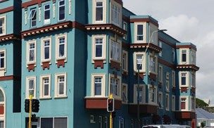

Heritage EQUIP Funded Projects 52

Devonport Flats, New Plymouth (advice)

Grant: $33,500
Grant Type: Professional Advice Grant
Date funded: May 2019

The Devonport Flats, located in central New Plymouth, is a four story apartment complex that consists of three separate but architecturally
related blocks. The buildings were designed by local architectural firm Messenger Griffiths and Taylor and constructed in reinforced concrete over the course of 1922-1924. The exteriors of the buildings were designed to a Stripped Classical design, and are painted in striking colours.

Heritage EQUIP funding is for the oldest of the three structures, the Dawson Block, which comprises eleven apartments. The grant will enable the owners to commission:

- a review and update of an earlier detailed seismic assessment
- a full structural design process comprising preliminary and detailed design
- cost estimation of the design
- a peer review of the detailed structural design.

Following this, in May 2020, a Heritage EQUIP upgrade works grant was awarded for the seismic strengthening works based on this detailed structural design.

Devonport Flats are a Heritage New Zealand Category 2 historic place.

Heritage New Zealand entry – Heritage New Zealand website

Heritage EQUIP Funded Projects 53

Hereford Chambers, Christchurch

Grant: $150,000
Grant Type: Upgrade Works Grant
Date funded: May 2020

Built in 1908, Hereford Chambers was designed in an Edwardian ‘Free’ style that complemented the large neighbouring commercial buildings that
once occupied this part of Hereford Street, forming a commercial precinct. Following the 2010 and 2011 Christchurch earthquakes, it is one of the rare remaining buildings of its type in the area.

The Heritage EQUIP upgrade works grant will go towards the following seismic strengthening:

Levelling of the southwest corner including reinstatement of foundation connections

Application of masonry ties, fibre-reinforced polymer, and fibre-reinforced grouting to brick walls

Establishing a ceiling diaphragm to the upper level, with associated wall and gable-end connections

Parapet repairs and connection into the roof structure.

Currently holding a heritage covenant on the title, following the completion of the works, Heritage New Zealand will review the building’s heritage status.

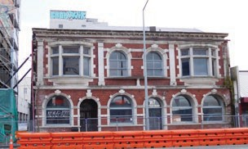

Heritage EQUIP Funded Projects 54

Grand Hotel Building, Palmerston North

Grant: $50,000
Grant Type: Upgrade Works Grant
Date funded: May 2020

Designed by prominent architect Joseph Clarkson Maddison in the Second Empire style, the Grand Hotel was built in 1906 to provide the finest accommodation in Palmerston North. Situated in the heart of the city on the Square, the Grand Hotel is a landmark of national historical significance.
The Hotel was used by Queen Elizabeth II when she visited in 1954 – the first reigning monarch to visit New Zealand.

The hotel closed in 1972, and the building is now
used for offices and retail.

The Heritage EQUIP professional advice grant will go towards a full structural design package including a structural design peer review and architectural and heritage advice.

The Grand Hotel Building is a Heritage New Zealand Category 1 listed place.

Heritage New Zealand entry – Heritage New Zealand website

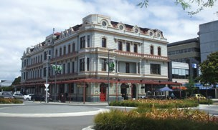

Heritage EQUIP Funded Projects 55

Masonic Lodge, Invercargill (works)

Grant: $150,000
Grant Type: Upgrade Works Grant
Date funded: May 2020

This Greek Revival Masonic building was built in 1926 to a design by Broderick and Royd and
constructed in brick and concrete. Featuring both notable exterior and the Greek Doric interior, the building is noted as probably the most impressive Masonic Lodge in New Zealand. Today, it is an impressive venue for hosting events and functions.

Following a Heritage EQUIP professional advice grant for structural assessment and design package in December 2019, this Heritage EQUIP upgrade works grant will go towards the seismic strengthening work which consists of:

- Masonry tying, including tying the front parapet and the portico to the main structure
- Strengthening and connecting the upper floor
diaphragm

- Removal and replacement of the chimney at the front of the building
- Repointing damaged mortar joints of the facade.

The Masonic Hall is listed by Heritage New Zealand as a Category 1 historic place.

Heritage New Zealand entry – Heritage New Zealand website

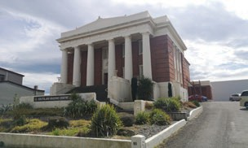

Heritage EQUIP Funded Projects 56

Masonic Lodge, Invercargill (advice)

Grant: $38,750
Grant Type: Professional Advice Grant
Date funded: December 2019

This Greek Revival Masonic building was built in 1926 to a design by Broderick and Royd and
constructed in brick and concrete. Both the exterior and the Greek Doric interior are notable, and it is probably the most impressive Masonic Lodge in New Zealand. Today, it is an imposing venue for hosting events and both private and charity functions.

A Heritage EQUIP professional advice grant has been awarded to the prospective purchasers of the building to secure a structural assessment and design package that will include:

- detailed seismic assessment (which includes a desktop geotechnical report)
- building survey
- concept structural design for both 34% and 67% NBS

- heritage or conservation architecture input to ensure appropriate heritage treatment
- detailed structural design.

Following this advice, in May 2020, a Heritage EQUIP upgrade works grant was awarded for the seismic strengthening based on the detailed structural design provided with the professional advice package.

The Masonic Hall is listed by Heritage New Zealand as a Category 1 historic place.

Heritage New Zealand entry – Heritage New Zealand website

Heritage EQUIP Funded Projects 57

Former Bank of New Zealand, Matamata

Grant: $28,350
Grant Type: Professional Advice Grant
Date funded: May 2020

The Bank of New Zealand building was opened in 1920 in Arawa Street, Matamata and one of the
first permanent buildings to be constructed in the growing town. Located in the centre of town, the landmark Edwardian baroque style building is the only heritage building on Arawa Street, representing the growth and prosperity of Matamata in the early 20th century.

A Heritage EQUIP professional advice grant will go towards a full structural design package along with a structural design peer review and architectural and heritage advice to inform the design.

The owners plan to retain the commercial use on the ground floor, with residential accommodation upstairs.

The building is listed as a Category 2 historic place with Heritage New Zealand.

Heritage New Zealand entry – Heritage New Zealand website

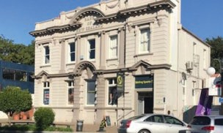

Heritage EQUIP Funded Projects 58

Mill House, Ashburton

Grant: $30,000
Grant Type: Upgrade Works Grant
Date funded: May 2020

Mill House was built in 1912 for the manager of the neighbouring Canterbury Flour Mill. It was designed by the England Brothers in the English Domestic Revival style. Currently a cafe, craft shop and craft education centre, Mill House has been associated with Ashford Handicrafts since the late 1970s.

Structural weaknesses were found to be the brick chimneys, and inadequate bracing to the existing timber framed walls. The chimneys have since been replaced with lightweight replicas, and lightweight materials replacing the previous tiled roof cladding.

A Heritage EQUIP upgrade works grant will go towards bracing the interior and exterior walls, and installing sub floor framing under the bracing walls.

Mill House is listed with Heritage New Zealand as a category 2 historic place.

Heritage New Zealand entry – Heritage New Zealand website

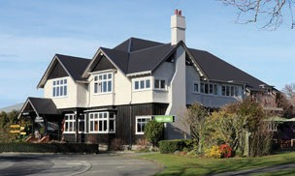

Heritage EQUIP Funded Projects 59

J.J. MacDonald Building, Marton

Grant: $30,900
Grant Type: Professional Advice Grant
Date funded: May 2020

The J.J. MacDonald Building was designed in the Edwardian free classical style by Invercargill architect Charles Brodrickon in 1908. Situated
on a prominent street corner it has architectural, aesthetic, and historic significance. The building is currently occupied by retail on the ground floor with residential accommodation above.

In 2018, the owners commissioned an initial seismic assessment and concept scheme which rated the building as 15%NBS. It identified in-plane weakness to the ground floors and out-of-plane weakness to the masonry upper level, including the parapets.

A Heritage EQUIP professional advice grant will go towards geotechnical and material strength
analysis, a detailed seismic assessment, preliminary and detailed strengthening design, an upgrade cost estimate, and a heritage impact analysis.

The building is listed as a Category 2 historic place with Heritage New Zealand and scheduled to the Rangitiki District Plan.

Heritage New Zealand entry – Heritage New Zealand website

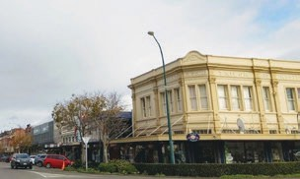

Heritage EQUIP Funded Projects 60

96 Lichfield Street, Christchurch

Grant: $250,000
Grant Type: Upgrade Works Grant
Date funded: May 2020

The Wellington Woollen Manufacturing Company built this new city centre warehouse and factory in 1919. Designed by the prominent architect William Henry Gummer, it was a technologically pioneering four-storeyed building supported by a grid of
40 reinforced concrete columns. Decorated in a stripped classical style, and an example of post WWI commercial architecture, the building is a valuable asset to the inner-city streetscape.

Some strengthening work in 2002 saw the building repurposed to student accommodation. However, the building was damaged in the 2010-2011 Christchurch earthquakes and has not be used since. Primarily due to the unreinforced stone facade, the building has a current rating of less than 34%NBS.

A Heritage EQUIP upgrade works grant will go towards pinning, bracing and repairing the facade, strengthening and re-connecting the walls/columns/ floors, along with new shear walls and support beams.

The building is listed with Heritage New Zealand category 1 historic place and listed as a heritage item on the Christchurch District Plan.

Heritage New Zealand entry – Heritage New Zealand website

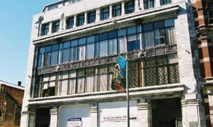

Heritage EQUIP Funded Projects 61

3 Rutland Street, Whanganui

Grant: $14,700
Grant Type: Professional Advice Grant
Date funded: May 2020

3 Rutland Street is the 1910 Art Nouveau style addition to the adjacent Cosmopolitan Club building. These buildings contribute significantly to the streetscape of Whanganui’s Arts and Culture precinct.

A 2018 detailed seismic assessment for the Rutland Street building identified the critical structural weaknesses as poor connections between the unreinforced masonry walls, roof and first floor, and the unreinforced masonry parapets.

A Heritage EQUIP professional advice grant will go towards a full structural design package including a structural design peer review and architectural and heritage advice.

The building is listed as a Category 2 historic place with Heritage New Zealand and scheduled as a heritage item in the Whanganui District Plan.

Heritage New Zealand entry – Heritage New Zealand website

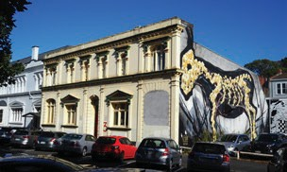

Heritage EQUIP Funded Projects 62

Royal Hotel, Timaru

Grant: $14,800
Grant Type: Professional Advice Grant
Date funded: May 2020

Home to Timaru’s second oldest pub licence, the former Royal Hotel is now used as offices and accommodation. Construction dates to the 1920’s and it’s corner location opposite the Grosvenor Hotel makes it an important streetscape contributor, maintaining essential character within the heart of the town.

A Heritage EQUIP professional advice grant will go towards a detailed seismic assessment and reporting, along with brick and mortar strength testing.

The building is listed as a Category 2 historic place with Heritage New Zealand and scheduled as a heritage item in the Timaru District Plan.

Heritage New Zealand entry – Heritage New Zealand website

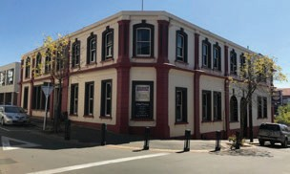

Heritage EQUIP Funded Projects 63

51 Gladstone Road, Gisborne

Grant: $30,000
Grant Type: Upgrade Works Grant
Date funded: May 2020

Built in 1871 by Henry Clayton, this original Kauri framed structure is the oldest wooden building in Gisborne’s CBD. It was among several trading stores built on Gladstone Road at that time. Due to fires in the late 1800s very few of these original buildings remain.

Various modifications have been made over the years, including significant unreinforced masonry additions between 1910 and 1930 and a third floor in 2002. The building is configured with three residential units upstairs and two cafe premises downstairs.

The building’s structural weaknesses are largely due to the unreinforced masonry walls and parapets.

The Hertiage EQUIP updgrade works grant will go towards the insertion of steel portal framing of all the first floor walls, tying back the masonry, and strengthening the parapets.

The building is scheduled as a heritage item in the Gisborne District Plan.

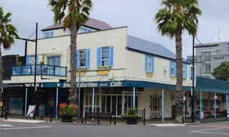

Heritage EQUIP Funded Projects 64

Hotel St Amand, Tauranga (works)

Grant: $150,000
Grant Type: Upgrade Works Grant
Date funded: December 2019

Hotel St Amand was built in 1918 to a reinforced concrete-framed brick infill design by local architect Herbert Henry Clemson. It is the only remaining hotel in The Strand from the days when the port was located alongside. Today Harbourside City Backpackers operate from the first floor and a restaurant occupies the ground floor.

The structural upgrade will result in the hotel having a seismic strength of 67%NBS. The work is based
on is based on structural design commissioned following an earlier Heritage EQUIP professional advice grant.

A Heritage EQUIP upgrade works grant of $150,000 enables the owners to:

- build reinforced concrete walls and footings to the
ground and first floor
- establish and improve floor/wall connections
- fix external posts as strongbacks on masonry side
walls

- fix strongback to masonry internal walls
- tie the parapet back to the roof structure.

It is a Heritage New Zealand listed Category 2 building.

Heritage New Zealand entry – Heritage New Zealand website

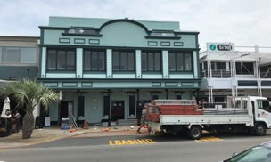

Heritage EQUIP Funded Projects 65

Hotel St Amand, Tauranga (advice)

Grant: $43,700
Grant Type: Professional Advice Grant
Date funded: May 2019

Hotel St Amand was originally a hotel built in 1918 to a reinforced concrete-framed brick infill design by local architect Herbert Henry Clemson. It is a Heritage New Zealand listed Category 2 building.

It is the only remaining hotel in The Strand from the days when people and goods arrived in Tauranga primarily by ship and accommodation was needed nearby. Today the upstairs of the building is occupied by the Harbourside City Backpackers and downstairs is a restaurant.

Heritage EQUIP funding supported the commissioning of:

- a detailed seismic assessment
- concept then detailed structural design supported by geotechnical advice
- design input from heriage architects to ensure the seismic solution reflects the building’s heritage values.

Following this advice, in December 2019, a Heritage EQUIP upgrade works grant was awarded for
the seismic strengthening based on the detailed structural design.

Heritage New Zealand List entry – Heritage New Zealand website

Heritage EQUIP Funded Projects 66

Grosvenor Hotel, Timaru (works)

Grant: $300,000
Grant Type: Upgrade Works Grant
Date funded: December 2019

The Grosvenor Hotel is situated on the corner of Cains Terrace and Beswick Street in central Timaru. It is a three-storey hotel with a cellar. It was designed by architect James S Turnbull and built by the Shillito Brothers in 1915 of brick and stone with cement and plaster. The brick and stone of the exterior created a striking polychromatic effect. The Grosvenor hosted the Queen during her state visit in 1954.

Facing significant changes to a very large building, the owner has adopted a staged approach to the project.

Earlier in 2019 the owners were awarded a Heritage EQUIP professional advice grant of $29,100 which allowed them to secure a structural design and peer review for the seismic upgrade work.

A Heritage EQUIP upgrade works grant of $300,000 for the works phase of the project will see:

- ceiling and floor diaphragms installed in the top floors
- timber strongbacks added to the top floor
- restraint of the parapets

- bracing to the top floor walls
- and masonry ties fixed to the exterior walls.

The Grosvenor is listed with Heritage New Zealand category 2 historic place.

Heritage New Zealand entry – Heritage New Zealand website

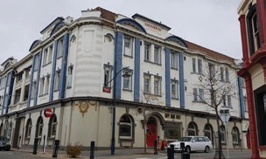

Heritage EQUIP Funded Projects 67

Grosvenor Hotel, Timaru (advice)

Grant: $29,100
Grant Type: Professional Advice Grant
Date funded: May 2019

The Grosvenor Hotel is situated on the corner of Cains Terrace and Beswick Street in downtown Timaru. It is a three-storey hotel with cellar. It was designed by architect James S Turnbull and built by the Shillito Brothers in 1915 of brick and stone with cement and plaster. The brick and stone of the exterior created a striking polychromatic effect. The Grosvenor hosted the Queen during her state visit in 1954.

The Heritage EQUIP professional advice grant supported the owner to secure a structural design and peer review for the seismic upgrade work.

Following this, in December 2019, a Heritage EQUIP upgrade works grant was awarded for the seismic strengthening based on the structural design secured through the professional advice grant.

The Grosvenor is listed with Heritage New Zealand category 2 historic place.

Heritage New Zealand entry – Heritage New Zealand website

Heritage EQUIP Funded Projects 68

Frankton Hotel, Hamilton

Grant: $40,000
Grant Type: Professional Advice Grant
Date funded: December 2019

Frankton Hotel was built in 1929 to a design by Jack Chitty. Historically Frankton has been an important North Island railway junction and commercial centre. Today, the Frankton Hotel continues as a licensed hotel, conference and function venue. The hotel features plastered masonry walls, terracotta tiled roof, timber doors and steel framed windows.

Having already commissioned a detailed seismic assessment, the owners have been awarded a Heritage EQUIP professional advice grant to complete structural design for the hotel upgrade.

The advice funded includes:

- a geotechnical report
- concept structural design
- detailed structural design with peer review
- architectural input to the design process to ensure appropriate heritage treatment.

This local landmark is listed with Heritage New Zealand as a category 2 historic place.

Heritage New Zealand entry – Heritage New Zealand website

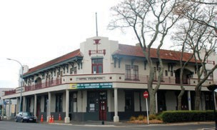

Heritage EQUIP Funded Projects 69

Oddfellows, Whanganui

Grant: $100,000
Grant Type: Upgrade Works Grant
Date funded: December 2019

This two-storied timber and weatherboard building was constructed in 1895 for the Oddfellows’ Whanganui Order. It was designed by HT Johns and built by Olliver & Simpson. Today it forms the eastern bookend of Ridgway Street’s block of heritage buildings and contributes to what is probably Whanganui’s most important heritage streetscape.

In addition to strengthening work, the owners will create two accommodation units upstairs and commercial space on the ground floor.

The building’s structural weaknesses are largely due to its narrow floor span and lack of lateral bracing. The proposed solution involves the insertion of a ground floor timber portal frame, plus bracing to the walls and roof. On completion of works, the building will have a seismic strength of 67%NBS.

The building is scheduled as a heritage item in the Whanganui district plan.

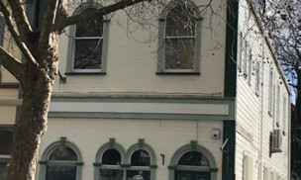

Heritage EQUIP Funded Projects 70

Hooson’s Building complex, Wellington

Grant: $250,000
Grant Type: Upgrade Works Grant
Date funded: December 2019

Located on a prominent corner in Wellington’s Courtenay Place, these five buildings are critical to the integrity of the Courtenay Place Heritage Area.

The upgrade scheme entails connecting the five buildings so that in the event of an earthquake they move as one. The main components of the seismic work are installation of shear walls supported by ground beams and clamping of the three Courtenay Place buildings together with torsional beams.
Completion of the project will see commercial and office space on upper floors and enhanced retail space at ground floor.

The owner wishes to restore some of the original historic features of the buildings, including ceiling mounted stained glass features that had been hidden and forgotten for half a century. Ornate mosaic flooring in the banking chamber vestibule entrance and cornicing throughout will also be restored.

Hooson’s Building (the corner building that extends down Tory Street) is listed as a Category 2 historic place with Heritage New Zealand, and the others are district plan scheduled.

Heritage New Zealand entry – Heritage New Zealand website

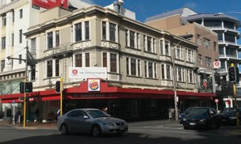

Heritage EQUIP Funded Projects 71

Tarbert Street, Alexandra

Grant: $60,957
Grant Type: Upgrade Works Grant
Date funded: December 2019

The Tarbert Street Dental Surgery was built in the 1880s as a chemist, and has been in continuous use as a dental surgery since the 1890’s. Its façade is constructed in Schist stone.

The building owners are also the operators of the dental surgery and the work will be undertaken with minimal disruption to business. The upgrade will address the out of plane capacity of its stone masonry wall and as strengthening is internal it will not impact the street appearance.

A new ceiling diaphragm with wall/ceiling connections will be constructed and there will be new steel reinforcement to the inside of the front façade. On completion of works the building will have a seismic strength of 67% NBS.

The building is scheduled as a heritage item in the Central Otago District Plan.

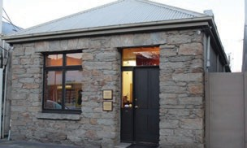

Heritage EQUIP Funded Projects 72

East Street Mission Hall

Grant: $150,000
Grant Type: Upgrade Works Grant
Date funded: December 2019

The Former Mission Hall was designed by architect Alex Wiseman and built by Lye & Sons. It is located on the east side of East Street, near Karangahape Road. When it opened 1909 it sat over 1,000 people with space for a choir and orchestra. The building also included two large classrooms and a study for the Minister. The hall has been used for lectures, concerts, fundraisers and as a meeting place for diverse groups, including the Methodist Women’s Union.

The Mission Hall’s current owners plan to repurpose the building while keeping the East Street façade unchanged. Major changes for the interior
include a establishing a new intermediate floor so accommodation units can be provided on the upper level of the building. Ground floor commercial space will also be provided.

Intermediate flooring will also strengthen the building as it braces the masonry side walls. Other work includes steel brace framing, columns, shear walls, and seismic separation from a neighbouring building. On completion of the works, the building will have a seismic strength of 100% NBS.

The Mission Hall is part of the Karangahape Road Historic Heritage Area and will be near to the new Karangahape city link station.

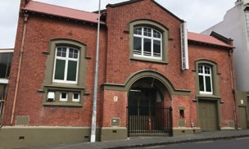

Heritage EQUIP Funded Projects 73

Six Buildings in Feilding

Grant: $85,760
Grant Type: Professional Advice Grant
Date funded: September 2019

Feilding has a substantial number of intact Edwardian buildings in its town centre. A council- led consultation process identified a group of six of these buildings as the town’s most important.
Although they have four different owners, all six are Heritage New Zealand Category 2 listed.

Together the building owners have tasked a single engineer to provide for each building a detailed seismic assessment, concept structural design, and high-level costing of that design. The fee proposal was the basis for a Heritage EQUIP multiple building application to part-fund the proposed advice.

This outcome is the result of successful partnership work between the building owners, Manawatu District Council, Heritage New Zealand, and Heritage EQUIP.

New Zealand Heritage List entry for 3 Manchester Square – Heritage New Zealand website

New Zealand Heritage List entry for Carthews Arcade – Heritage New Zealand website

New Zealand Heritage List entry for 70 Manchester Street – Heritage New Zealand website

New Zealand Heritage List entry for 72 Manchester Street – Heritage New Zealand website

New Zealand Heritage List entry for Feilding Hotel – Heritage New Zealand website

New Zealand Heritage List entry for Bank of New Zealand (former) – Heritage New Zealand website

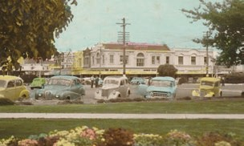

Heritage EQUIP Funded Projects 74

Masonic Hotel, Cambridge (works)

Grant: $300,000
Grant Type: Upgrade Works Grant
Date funded: October 2019

Cambridge’s Masonic Hotel on Duke Street was built in 1912 in an Edwardian Classical design by
Auckland architect John Currie. Providing hospitality to locals and visitors to Cambridge for over a century, the Masonic is a significant landmark in the town.
The building is currently in use as a backpackers, restaurant, gaming lounge and bar.

In May 2019 the owners of the Masonic Hotel were awarded a Heritage EQUIP professional advice grant of $36,900. With this grant they were able to commission a detailed structural and architectural design for the building.

This Heritage EQUIP upgrade works grant of
$300,000 will go towards seismic strengthening aspects of the work to the building, including securing the parapets and chimneys, improving the floor and roof diaphragms, and installing first floor cavity ties.

Once both the seismic strengthening and wider redevelopment of the property is complete, the owners plan to reopen the Masonic Hotel as a high- end boutique hotel.

New Zealand Heritage List entry – New Zealand website

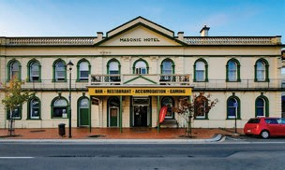

Heritage EQUIP Funded Projects 75

Masonic Hotel, Cambridge (advice)

Grant: $36,900
Grant Type: Professional Advice Grant
Date funded: May 2019

Cambridge’s Masonic Hotel on Duke Street was built in 1912 to an Edwardian Classicism design by
Auckland architect John Currie. Providing hospitality to locals and visitors to Cambridge for over a century, the Masonic is a significant landmark in the town.
The building is currently in use as a backpackers, restaurant, gaming lounge and bar.

With the assistance of a Heritage EQUIP professional advice grant the owners have commissioned detailed structural and architectural design.

Following this professional advice, in October 2019, a Heritage EQUIP upgrade works grant was awarded for seismic strengthening based on the detailed structural and architectural design.

The Masonic Hotel is Heritage New Zealand listed category II.

Heritage New Zealand entry – Heritage New Zealand website

Heritage EQUIP Funded Projects 76

Preston Building, Hokitika

Grant: $56,028
Grant Type: Upgrade Works Grant
Date funded: September 2019

This building was probably the first reinforced concrete building in Hokitika. It was owned by the Preston family (originally drapers) from completion in 1923 until 2017. This strengthening project entails installing a steel frame inside the front façade to improve the in plane and out of plane performance of the building in an earthquake. This relatively simple engineering solution will enable the building to continue in use as a retail shop in the Hokitika town centre.

New Zealand Heritage List entry – Heritage New Zealand website

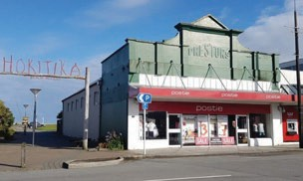

Heritage EQUIP Funded Projects 77

Shoestore, Inglewood

Grant: $11,750
Grant Type: Professional Advice Grant
Date funded: September 2019

The Shoestore in Inglewood is a local landmark also known as the Messenger Building after it’s architect Frank Messenger. The concrete party wall on the western side is the only earthquake-prone building element.

A Heritage EQUIP professional advice grant will support:

- geotechnical investigation of ground conditions
- detailed design for structural strengthening the party wall
- ancilliary advisory services like a design features report and preparation of consent documents.

New Zealand Heritage List – Heritage New Zealand website

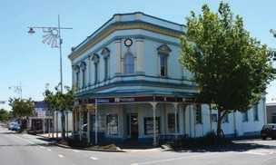

Heritage EQUIP Funded Projects 78

Dorset Street Flats

Grant: $200,000
Grant Type: Upgrade Works Grant
Date funded: September 2019

The Dorset Street Flats in Christchurch were designed in 1956 by architect Sir Miles Warren as small-scale owner-occupier flats. They were built to a modernist, new-brutalist inspired design whose key innovation was the use of load-bearing concrete block. The style became known as the “Christchurch School” which challenged and influenced the work of other architects. The buildings are recognised as a Category 1 historic place by Heritage New Zealand.

In the Canterbury earthquakes the complex sustained major damage. After an insurance settlement the owners still had a significant funding shortfall and residual structural weaknesses.

Heritage EQUIP funding will support upgrade work that includes:

- addressing the capacity of the ground and first floor concrete block walls with shear walls and associated ground beams
- replacing unreinforced concrete block with timber framed walls in some areas
- establishing a plywood diaphragm at roof level
- establishing transfer trusses to ensure new shear walls and diaphragms deal with earthquake loads appropriately.

New Zealand Heritage List entry – Heritage New Zealand website

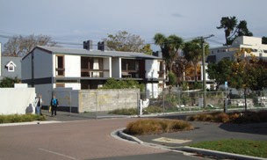

Heritage EQUIP Funded Projects 79

Stewart Dawson’s Corner, Wellington

Grant: $150,000
Grant Type: Upgrade Works Grant
Date funded: September 2019

Stewart Dawson’s Corner comprises three Victorian/Edwardian era commercial buildings constructed separately between 1887 and 1903. All three buildings were designed by prominent local architects and form a landmark at the corner of Lambton Quay and Willis Street. The buildings are all listed with Heritage New Zealand and scheduled to the District Plan. They are also critical elements of the south Lambton Quay historic precinct.

The project entails pinning the original historic façades of each building to a new podium which form part of a new ten-level office development. Although the building behind the façades will be new, some heritage fabric from the old building will be reinstated. This includes the historic timber roof trusses.

New Zealand Heritage List entry for Stewart Dawson’s Building – Heritage New Zealand website

New Zealand Heritage List entry for United Fruit Company Building – Heritage New Zealand website

New Zealand Heritage List entry for City Meat Company Building – Heritage New Zealand website

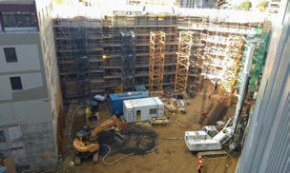

Heritage EQUIP Funded Projects 80

New City Hotel, Christchurch

Grant: $250,000
Grant Type: Upgrade Works Grant
Date funded: September 2019

The New City Hotel is one of the last remaining historic hotels in the Christchurch city centre. It was constructed in 1930 in the Moderne style by
architect John Steele Guthrie. His design was heavily influenced by American architectural trends. The building is recognised as a Category 2 historic place by Heritage New Zealand.

The strengthening scheme will address capacity in the structural columns, and capacity of the masonry walls and parapets. Work will include foundation beams, creation of structural diaphragms, and lateral load bracing elements.

New Zealand Heritage List entry – Heritage New Zealand website

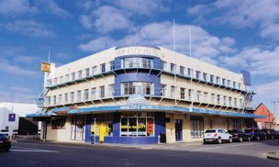

Heritage EQUIP Funded Projects 81

195 Jackson Street, Petone

Grant: $100,000
Grant Type: Upgrade Works Grant
Date funded: September 2019

This building was constructed in 1928 and has seen little alteration since. The modest structure comprises of two apartments on the upper level and two retail shops below. This building makes an
important contribution to the Heritage New Zealand listed Jackson Street Historic Area.

The upgrade scheme will see installation of ground beams and steel portal frames to strengthen the walls and improve resistance to lateral earthquake forces.

New Zealand Heritage List entry – Heritage New Zealand website

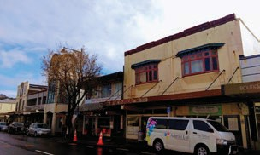

Heritage EQUIP Funded Projects 82

Dominion Hotel, Timaru

Grant: $50,000
Grant Type: Professional Advice Grant
Date funded: September 2019

The Dominion Hotel opened in 1912 at the Bay Hill end of Timaru’s Stafford Street. The façade is built in an English Renaissance style, with plastered brick and Oamaru stone detailing. The building is currently vacant and requires extensive work.

Heritage EQUIP funding will support the owners to commission:

- a detailed seismic assessment
- concept and then detailed structural design
- architectural oversight for the structural design process to ensure heritage values are maintained.

The owners aim to restore the building to its former glory and operate a boutique accommodation business from the hotel.

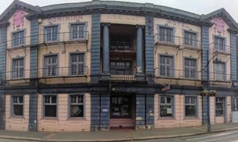

Heritage EQUIP Funded Projects 83

Norwich Quay, Lyttelton

Grant: $25,000
Grant Type: Upgrade Works Grant
Date funded: September 2019

9 Norwich Quay was built in 1865, purpose built as the Lyttelton telegraph office. This diminutive waterfront landmark is a picturesque reminder of
Lyttelton’s early colonial history and sits within the HNZPT Lyttelton Township Historic Area.

The building has been unoccupied since damage was sustained during the Canterbury earthquakes.

Funding will support installation of steel portal frames on new foundations. Steel beams and vertical bracing will improve the earthquake resisting

capacity of the brick masonry walls. Bracelining will
also be introduced to the first-floor.

On completion of the work the upper level will be reinstated as a residential apartment and the lower floor established as a commercial workspace.

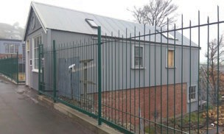

Heritage EQUIP Funded Projects 84

DC Turnbull, Timaru

Grant: $50,000
Grant Type: Professional Advice Grant
Date funded: September 2019

The DC Turnbull is a complex of adjacent grain and wool store buildings constructed since the 1880s in varying architectural styles. The final building of the group is the two level administration building facing Strathallan Street. It was built to an Edwardian commercial classicism design by his architect brother, James Turnbull.

Three older brick and timber buildings adjoin the rear of the administration building and also incorporate an early 1900’s tramway, tunnel and
siding. Heritage New Zealand recognise the complex as a Category 2 building.

A Heritage EQUIP grant will support the owners to secure:

- a three stage structural design package (concept, then developed, then detailed design), including geotechnical input
- a heritage impact assessment at the structural concept design stage, and ongoing heritage architecture input to the design process
- quantity surveying advice at both concept and detailed design stage
- support with consenting documentation.

New Zealand Heritage List entry – Heritage New Zealand website

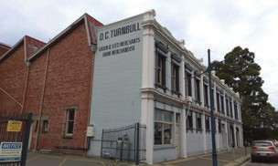

Heritage EQUIP Funded Projects 85

St Aubyn Chambers, New Plymouth (advice)

Grant: $50,000
Grant Type: Professional Advice Grant
Date funded: May 2019

Picturesque St Aubyn Chambers was built in 1927 to a design by architect Francis Messenger on a
prominent corner site. It was originally designed for Jones and Sandford, a building firm first established in 1918. It was the first in-situ concrete building in New Plymouth and among the first in New Zealand. The building underwent several alterations between 1968 and 1983, and the ground floor was enclosed in 1982. Today it comprises six residential apartments.

The Heritage EQUIP Professional Advice Grant of $31,990 supported the owners to commission structural and architectural design advice, along with heritage impact analysis. A second Heritage

EQUIP grant of $18,010 awarded in September 2019 supports the owners to seek further professional advice.

St Aubyn Chambers is Heritage New Zealand listed category 2.

Heritage New Zealand List entry – Heritage New Zealand website

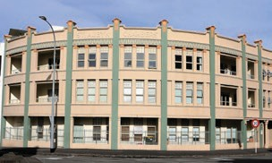

Heritage EQUIP Funded Projects 86

Poppelwells Building, Hastings

Grant: $50,000
Grant Type: Upgrade Works Grant
Date funded: May 2019

Poppelwells is a rare pre-Napier earthquake commercial building designed by Alfred Garnett in the Spanish Mission style. The façade is unchanged from when it was originally built in 1924. It is of reinforced concrete construction with timber framed roof, eaves and verandah.

The building has wide frontage to the railway line and is a familiar building to the pedestrians of central Hastings. The building’s name came from the clothing firm, Poppelwells, who owned the property between 1964 and 2004. Today it continues in its original commercial purpose. It is a Heritage New Zealand Category 2 historic place.

The strengthening scheme entails installing steel sections to secure the upper floor walls, and installation of steel brace framing on the ground floor.

New Zealand Heritage List entry – Heritage New Zealand website

Hastings District Council heritage inventory report

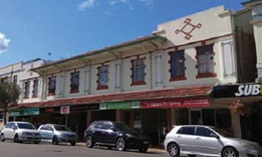

Heritage EQUIP Funded Projects 87

Berry Building, Wellington

Grant: $42,472
Grant Type: Upgrade Works Grant
Date funded: May 2019

The Berry Building at 145 Cuba Street is an Edwardian Classical commercial building. It makes a significant contribution to the streetscape of Wellington’s Cuba Street Historic Area. It was built in 1900 to a design by architect William Crichton as a studio for William Berry and his photography business. Berry took many portraits of young men
about to embark for military service overseas during the First World War, the collection of which is now housed at Te Papa Museum.

The building continued to be used as a photography studio until the 1940s and was later established as an art gallery by well-known New Zealand artist Peter McLeavey ONZM. The gallery has exhibited some
of New Zealand’s most prominent artists, including Colin McCahon and Toss Woollaston.

The current owners undertook substantial seismic strengthening works and refurbished the interior in 2001. This grant of $42,472 from Heritage EQUIP will allow the owners to complete their work on the historic property by securing the brickwork with anchor ties.

Wellington City Council heritage listing

New Zealand Heritage List entry – Heritage New Zealand website

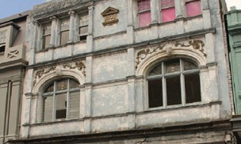

Heritage EQUIP Funded Projects 88

131 Jackson Street, Petone

Grant: $100,000
Grant Type: Upgrade Works Grant
Date funded: May 2019

Built in 1926, 131 Jackson Street is an Inter-War Georgian style building designed by well-known Wellington architect William Gray Young. It contributes to the streetscape of the Jackson Street Historic Area.

This Heritage EQUIP grant of $100,000 will enable the owners to implement a solution that includes installing steel portals with ground beams, a concrete shear wall, diaphragms, tying of the parapet and gable ends, and addition of steel strongbacks.

New Zealand Heritage List entry – Heritage New Zealand website

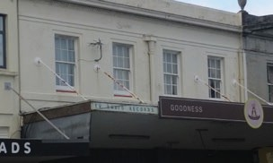

Heritage EQUIP Funded Projects 89

Former Chief Post Office, Christchurch

Grant: $250,000
Grant Type: Upgrade Works Grant
Date funded: May 2019

Today, the former Chief Post Office is one of the oldest buildings in Cathedral Square. It was built between 1877 and 1879 to a design by William Clayton, New Zealand’s first and only Colonial Architect. The brick building is designed in an Italianate style combining Classical and Venetian Gothic elements. There is a clock tower on the east façade and a prominent British coat of arms above the main entrance. The building functioned as the Chief Post Office for 113 years, which at times also housed the Immigration, Customs and Public Works departments. In 1881, New Zealand’s first telephone exchange was installed there.

This important building is a landmark in inner-city Christchurch and is recognised as a Heritage New Zealand Listed Category 1 building. It has sustained some earthquake damage and the $250,000 grant from Heritage EQUIP will contribute to the cost of a comprehensive repair and strengthening process.

This will include work on foundations, establishing structural diaphragms, and installing steel framing.

Christchurch City Council heritage schedule entry

Christchurch City Libraries description of the building

New Zealand Heritage List entry – Heritage New Zealand website

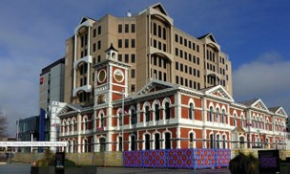

Heritage EQUIP Funded Projects 90

Former Kilwinning Lodge, Lyttelton

Grant: $150,000
Grant Type: Upgrade Works Grant
Date funded: May 2019

Kilwinning Lodge was built in 1881 on a Canterbury Street property overlooking Lyttelton Harbour. It was originally a single-story masonry structure, named in honour of what is believed to be the oldest
masonic lodge in Scotland. The building was partially gutted by fire in 1903, but when it was restored later that year the owners took the opportunity to add
the façade and a timber second floor. The building continued in use as a meeting place of the Lyttelton Masonic Lodge for almost 120 years.

Well-known New Zealand artist Bill Hammond later used the space as a studio during the 2000s, until
it was severely damaged in the 2010-11 Canterbury earthquakes. The lodge was in poor repair when structural engineering firm Structex purchased the property in 2015.

This Heritage EQUIP grant of $150,000 will allow Structex to continue with the extensive
strengthening work required, which includes raising the upper floor, removal of unreinforced masonry walls, retaining, repairing and reconnecting the façade, and the addition of steel framing.

The lodge is part of the Lyttelton Township Historic Area.

New Zealand Heritage List entry – Heritage New Zealand website

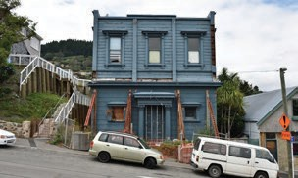

Heritage EQUIP Funded Projects 91

Jubilee Hall, Blind Foundation, Parnell

Grant: $250,000
Grant Type: Upgrade Works Grant
Date funded: May 2019

The Jubilee Hall is attached to the rear of the prominent Category 1 listed Royal New Zealand Foundation of the Blind Main Building in the Auckland suburb of Parnell. Designed by noted architect Edward Bartley, it was built as the last element of the main structure in 1909, completing the first purpose-built facility and residential school for the blind in New Zealand.

The tidy red brick hall makes a significant contribution to the complex both because of its unique history and ongoing use by the wider community.

This grant of $250,000 will enable a company associated with the Blind Foundation to undertake work involving masonry ties, ground beams, columns, and improvements to the roof-wall connections.

New Zealand Heritage List entry – Heritage New Zealand website

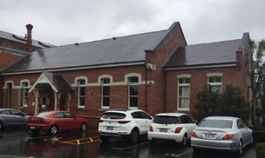

Heritage EQUIP Funded Projects 92

St James, Auckland

Grant: $1,500,000
Grant Type: Upgrade Works Grant
Date funded: June 2017

St James Theatre has been awarded $1.5 million. The grant will contribute towards the costs of foundation piling and substructure works, in preparation for base isolation.

The St James Theatre was built in 1928 to replace the Fullers Opera House which had been destroyed by fire in 1926. Designed by Henry Eli White, it was
intended to host travelling vaudeville acts. Projection equipment was added in 1929 to allow the theatre to show films.

The building includes traditional theatre elements such as three steep tiers of seating, boxes and high quality acoustics in the main auditorium.
The interior is a Spanish Colonial style featuring statuettes, marble steps and elaborate lighting.

St James Theatre is listed as a Category 1 historic place on the New Zealand Heritage List. The building is also scheduled as Category A building on the Auckland Unitary Plan.

New Zealand Heritage List entry – Heritage New Zealand website

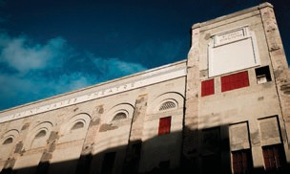

Heritage EQUIP Funded Projects 93

Bank of New South Wales, Whanganui

Grant: $230,637
Grant Type: Upgrade Works Grant
Date funded: September 2017

The Bank of New South Wales upgrade project was awarded a $230,637 grant. The building owners have investigated 34% NBS and 67% NBS strengthening options that include:

- tying back the façade and parapet
- installing shear walls
- adding new diaphragms
- installing cross bracing

Designed by Wellington architects Crichton and McKay, the building was constructed in 1910 by local builders Russell and Bignell.

The two story building has unreinforced clay brick masonry walls and timber joinery. The internal banking chamber features an impressive Wunderlich

pressed steel ceiling and concrete columns with plaster ornamentation.

The Bank of New South Wales building is listed as a Category 2 historic place on the New Zealand Heritage List and a Class B heritage item on the council’s district plan.

New Zealand Heritage List entry – Heritage New Zealand website

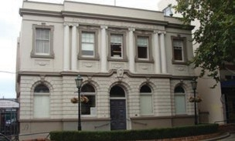

Heritage EQUIP Funded Projects 94

Lambretta’s, Nelson

Grant: $174,700
Grant Type: Upgrade Works Grant
Date funded: June 2017

Stage one of the former New Zealand Insurance company (NZI) building upgrade project was awarded $94,700. The grant contributed towards:

- securing the masonry parapets to the roof trusses
- retrofitting roof and wall bracing to restrain
columns and distribute their loads.

Stage two of the project was supported with $80,000 of funding for works to strengthen the ground
floor masonry infill walls against pounding by the
building adjacent.

The building is currently used as a restaurant and office space. Lambretta’s Café Bar, the ground floor tenant, will vacate the building while ground floor works are completed as part of stage two.

Designed in a Modern Neoclassical style by Gummer
& Ford and Nelson architect Alexander Bowman,

the building was constructed for the New Zealand Insurance company in 1956.

The two-storey building was built by C Gibbons and made from concrete, brick and steel. It has an L-shaped footprint and mono-pitch roof concealed by a plain parapet. ‘Curtain-wall’ fenestration on the north-facing façade is recessed behind two
large freestanding columns with bronze detailing at capital and base.

The building is registered on the New Zealand Heritage List as a Category 2 historic place and a Heritage Category C in the council’s district plan.

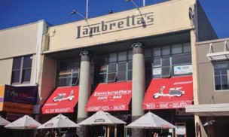

Heritage EQUIP Funded Projects 95

The Pumphouse, Christchurch

Grant: $200,000
Grant Type: Upgrade Works Grant
Date funded: June 2017

The Pumphouse upgrade project has been awarded
$200,000. The grant will contribute to the costs of:

- installation of roof diaphragms
- repairing and tying brickwork
- improving connections between the roof, walls
and floor
- installing brace framing.

The Pumphouse is made up of a collection of buildings that were the former Waterworks Pumping Station. The pumping station was built in the 1870s to resolve the city’s sewage and drainage problems.

The buildings have gabled roofs, restrained classical detailing constructed with Oamaru stone, distinctive arched windows and doors, multi paned steel windows and round windows in some of the gables. The roofs are a combination of slate and corrugated iron.

From 1923 to 1989 the site was used as the drainage board workshops. Since 1990 a demolition business has operated on the site.

The Pumphouse is listed on the New Zealand Heritage List as a Category 2 historic place. It is also listed on the council’s district plan.

New Zealand Heritage List entry – Heritage New Zealand website

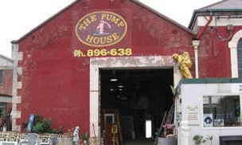

Heritage EQUIP Funded Projects 96

Gallate’s Building, Napier

Grant: $14,753
Grant Type: Upgrade Works Grant
Date funded: June 2017

The Gallate’s Building has been awarded $14,753 to strengthen the unreinforced masonry side walls. This will be completed by bolting beams under the roof framing to connect each wall. This is a relatively low cost solution that lifts seismic performance of the walls to above 34% NBS.

The building was constructed in 1932 following the Napier earthquake. The two story building was designed by JA Louis Hay, in the Art Deco style
prevalent at that time. It was built by Holder Bros and constructed from brick and reinforced concrete.

The building has been maintained in the Art Deco style and contributes to the iconic Art Deco streetscape of Napier.

The Gallate’s Building is a Group 1 heritage building on the Napier District Plan. It is also included on the New Zealand Heritage List as part of the Napier City Centre Historic Area.

New Zealand Heritage List entry – Heritage New Zealand website

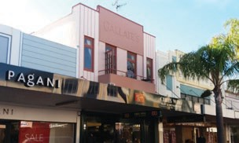

Heritage EQUIP Funded Projects 97

Mid City Plaza, Napier

Grant: $150,000
Grant Type: Upgrade Works Grant
Date funded: June 2017

Mid City Plaza is a collection of interconnected buildings located between Emerson Street and Dickens Street in Napier. A project to strengthen the Dickens Street building was awarded $150,000. The grant contributed to the costs of:

- removing the unreinforced concrete first floor and
replacing with a timber diaphragm structure
- steel bracing on the first floor
- constructing ground floor foundations and shear
walls.

The two story building on Dickens Street was designed by EA Williams and constructed for the Hawke’s Bay Farmers Co-operative Association. It was built in the early 1920’s and survived the 1931 Napier earthquake.

The building consists of reinforced concrete columns and beams. The side and rear elevations are a plain plaster finish over concrete. The original façade has been altered since the 1920’s with the addition of a veranda and alterations to the original steel framed windows.

The Dickens Street building is a Group 1 heritage item on the Napier District Plan. It is also included on the New Zealand Heritage List as part of the Napier City Centre Historic Area.

New Zealand Heritage List entry – Heritage New Zealand website

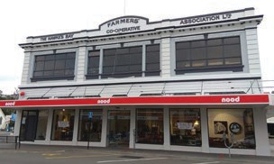

Heritage EQUIP Funded Projects 98

AE Kitchen Building, Whanganui

Grant: $15,700
Grant Type: Upgrade Works Grant
Date funded: August 2017

The AE Kitchen building has been awarded $15,700. The grant will contribute towards the costs of:

- tying back the decorative façade columns to the façade
- tying the balustrade to the façade
- restraining the side parapets to the roof and tying with the front parapet.

The AE Kitchen building was constructed by Nicolas Meuli in 1909. The two storey unreinforced clay brick masonry building is a classic example of Edwardian Baroque architecture.

The building was originally constructed as a pharmacy for Albert Edward Kitchen. It has remained largely unchanged, both internally and externally,

since it was built. Today, the ground floor is used as a retail space and the first floor has been refitted as residential accommodation.

The AE Kitchen building is listed as a heritage building in the council’s district plan. It occupies a prominent position on Whanganui’s main shopping street and is an important contribution to the historic townscape.

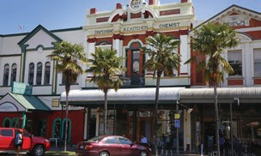

Heritage EQUIP Funded Projects 99

Union Steamship Company Store, Dunedin

Grant: $12,000
Grant Type: Upgrade Works Grant
Date funded: March 2017

The former Union Steamship Company Store has been awarded $12,000 towards strengthening one of its floors, as part of a major refit.

The Union Steamship Company store was originally
a warehouse for the South Pacific shipping company.
The restoration project will see the building turned into apartments and offices and comprise yet another success story in the revitalisation of Dunedin’s warehouse precinct.

The Union Steamship Company Offices and Stores are a Category 1 historic place on the New Zealand Heritage List.

New Zealand Heritage List entry – Heritage New Zealand website

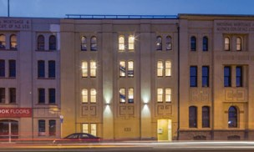
Heritage EQUIP Funded Projects
100

The National Tobacco Company Building, Napier

The National Tobacco Company building has been awarded $10,000 towards parapet strengthening.
The building is a Category 1 historic place on the New Zealand Heritage List.

Grant: $10,000
Grant Type: Upgrade Works Grant
Date funded: May 2017
The building was originally used as a tobacco processing factory, but will soon be home to a craft brewery and urban winery. The art deco entrance was designed and built after the original structure was damaged in the 1931 Hawke’s Bay earthquake and the iconic design has made this building a major tourist attraction.
New Zealand Heritage List entry – Heritage New Zealand website

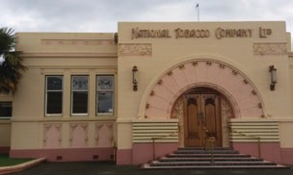
Heritage EQUIP Funded Projects
101

Milton Street Substation, Sydenham, Christchurch

Grant: $186,709
Grant Type: Upgrade Works Grant
Date funded: May 2018
One of Christchurch’s largest early substations will be strengthened with the support of $186,709 in Heritage EQUIP funding.

The building is the largest of the ornamental, classically influenced substations built in Christchurch during the 1920s and 1930s.
A significant landmark for this part of the city, much of the architectural detailing on the building is unique.

The building has a Group 2 listing in the Christchurch District Plan Schedule of Significant Historic Heritage.
Christchurch City Council district plan listing for the building

Read about the building in an article about substation restorations

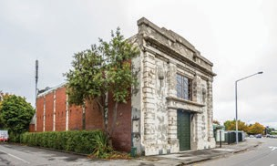
Heritage EQUIP Funded Projects
102

Marshall Building, Oamaru

Grant: $48,000
Grant Type: Upgrade Works Grant
Date funded: January 2018
The Marshall Building upgrade project was awarded $48,000 towards steel bracing, floor diaphragms, and securing work for the façade and parapet.

Designed in the 1880s by prominent architectural firm Forrester and Lemon, the two-storey commercial building features an ornate Oamaru Stone façade.
Located within the Heritage New Zealand listed Oamaru Historic Area, the building is currently empty and badly deteriorated. Once strengthened, the building will be converted into accommodation for visitors to Oamaru.

Oamaru Historic Area – Heritage New Zealand website

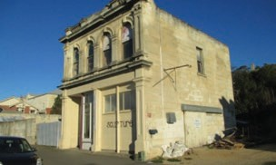
Heritage EQUIP Funded Projects
103

135–141 Jackson Street, Petone

Grant: $100,000
Grant Type: Upgrade Works Grant
Date funded: March 2018
Two connected buildings located along Petone’s main shopping street have been awarded $100,000. The grant will be used towards foundation and bracing work including steel portals and a shear wall. The owners fast-tracked seismic upgrade work because Hutt City Council required façade- strengthening under amendments made to
the Building Act after the Hurunui/Kaikōura
earthquakes.

Designed by prominent New Zealand architect William Gray Young, both buildings were constructed in 1926. The buildings contribute to the Heritage New Zealand listed Jackson Street Historic Area and the heritage area scheduled in the district plan.
Once upgraded, the buildings will provide four retail spaces on the ground floor and four residential spaces on the first floor.

Jackson Street Historic Area – Heritage New Zealand website

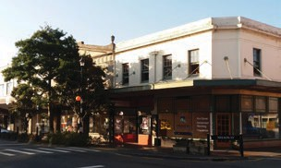
Heritage EQUIP Funded Projects
104

Hurunui Hotel, Hawarden

Grant: $132,503
Grant Type: Upgrade Works Grant
Date funded: January 2018
The Hurunui Hotel was awarded $132,503 towards strengthening work including the repair of stonework damaged in the Hurunui/Kaikōura earthquakes.

Built in 1868, the Hurunui Hotel holds one of the oldest operating licences in New Zealand. The two- storey building was constructed from layers of local hand-hewn limestone blocks packed with a mixture of tussock, clay and lime.
The hotel is a Category 1 historic place on the New Zealand Heritage List and listed as an archaeological site.

New Zealand Heritage List entry – Heritage New Zealand website

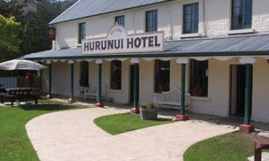
Heritage EQUIP Funded Projects
105

200 Willis Street, Wellington

Grant: $294,857
Grant Type: Upgrade Works Grant
Date funded: May 2018
The former Red Cross Building has been awarded
$294,857 of Heritage EQUIP funding for a comprehensive seismic upgrade.

The prominent Edwardian-era Tudor-style building was designed by William Turnbull and completed in 1908. Originally built as a residence and surgery for the well-respected surgeon Sir Donald McGavin, it later became home to the United Industries Club for women and girls, before it was sold to the Red Cross. Most recently the building has had residential and office uses.
The building is a Category 1 historic place on the New Zealand Heritage List and scheduled as a heritage building in the Wellington District Plan.

Building listing on Wellington City Heritage Inventory

New Zealand Heritage List entry – Heritage New Zealand website

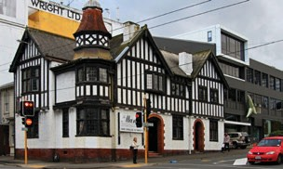
Heritage EQUIP Funded Projects
106

Archie’s Bunker Backpackers, Napier

Grant: $52,632
Grant Type: Upgrade Works Grant
Date funded: May 2018
The seismic upgrade of a rare example of international style architecture in Napier has been awarded $52,632 in funding.

The building was built as the offices of the Automobile Association in 1939. It was designed by LG Williams, who also worked on the Hawke’s Bay Museum and Art Gallery building opposite. It now operates as backpackers’ accommodation, serving tourists, seasonal workers and other visitors to Napier.
Archies Bunker is a contributing building to the Napier City Centre Historic Area listed with Heritage New Zealand.

New Zealand Heritage List entry – Heritage New Zealand website

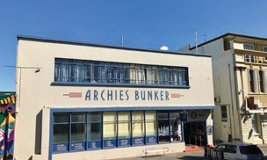
Heritage EQUIP Funded Projects
107

TG Macarthy Building, Wellington

Grant: $250,000
Grant Type: Upgrade Works Grant
Date funded: September 2017
The TG Macarthy building was awarded $250,000 towards seismic upgrade work on foundations, shear walls, diaphragms and tying back the façade.

Designed by James O’Dea in 1897, the late Victorian commercial building had an additional storey added in 1904. The building’s classical façade includes round-headed windows embellished with pilasters, architraves and keystones.

The TG Macarthy building is a Category 2 historic place on the New Zealand Heritage List and an important contributor to the Cuba Street Historic Area.
After the project’s completion, the ground floor will continue to provide retail space while the currently vacant upper floors will offer character office space.

Building history – Wellington City Council website

New Zealand Heritage List entry – Heritage New Zealand website

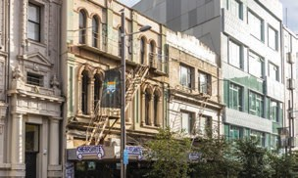
Heritage EQUIP Funded Projects
108

Ford Motor Company Workshop, Lower Hutt

Grant: $273,448
Grant Type: Upgrade Works Grant
Date funded: September 2017
A project to strengthen Ford Motor Company Workshop was awarded $273,448. The funding will assist with upgrading the foundations and columns, installing shear walls and bracing.

Constructed in 1935, the industrial building has steel frames and an impressive north facing glass curtain walls.

The workshop was originally used to assemble cars from imported parts. During World War II the building was used for the production of munitions, explosives, and the construction of army jeeps.
The Ford Motor Company Workshop is listed as a Category 2 historic place on the New Zealand Heritage List.

New Zealand Heritage List entry – Heritage New Zealand website

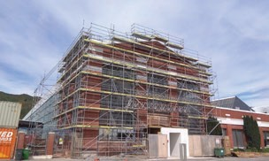
Heritage EQUIP Funded Projects
109

Albemarle Hotel, Wellington

Grant: $300,000
Grant Type: Upgrade Works Grant
Date funded: September 2019
Designed by Scottish architect James Bennie and built in 1906, this former hotel has unreinforced masonry brick walls, timber floors and a timber roof. It features an ornate Italianate façade and octagonal cupola that has been secured by previous strengthening work.

The building is locally significant as a hotel or boarding house within Wellington’s Cuba Street precinct. It changed hands several times but was best known as the unofficial headquarters of the leaders of the 1913 Great Strike.

In September 2019 the owners of the Albemarle Hotel were awarded a $300,000 Heritage EQUIP works grant. Their comprehensive project will include strengthening the foundations, shear walls and diaphragms.
With both architectural and social significance, the building is listed as a Category 2 historic building on the New Zealand Heritage List and a heritage building in the Council’s district plan.

New Zealand Heritage List entry – Heritage New Zealand website

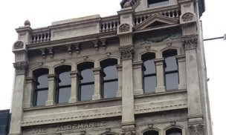
Heritage EQUIP Funded Projects
110

Munster Chambers, Napier

Grant: $17,500
Grant Type: Upgrade Works Grant
Date funded: June 2017
Munster Chambers has been awarded $17,500 towards the costs of removing the internal non- structural unreinforced masonry walls. In addition to the walls contributing to building mass, they posed a risk to building occupants.

The building was designed by architects J.A. Louis Hay and Natusch & Sons, with construction completed in 1933 by Curtlett Construction Co.

Munster Chambers is a single story building in the Art Deco style. The perimeter is reinforced concrete frames with double leaf masonry infill. Internal walls are generally single leaf unreinforced masonry with a nominal amount of timber frame infill.
The building is on the New Zealand Heritage List as a Category 2 historic place and included as part of the Napier City Centre Historic Area. It is also a Group 1 heritage item on the Napier District Plan.

The building is currently used as a commercial
premises by law firm Sainsbury Logan & Williams.

New Zealand Heritage List entry – Heritage New Zealand website

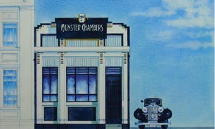
Heritage EQUIP Funded Projects
111

126 Cuba Street, Wellington

Grant: $100,000
Grant Type: Upgrade Works Grant
Date funded: May 2018
Heritage EQUIP is providing $100,000 towards a significant seismic upgrade of this office, residential and retail building in the city’s iconic Cuba Mall. The project involves installing a multi floor K-brace, and strengthening diaphragms and strongbacks.

Designed by notable Christchurch architect Joseph Clarkson Maddison, this building’s imposing Edwardian façade is the tallest in this block of the Cuba Mall precinct. Earthquake strengthening completed in the early 2000s tied the building to its neighbour.
The building is a contributing building to the Cuba Street Historic Area listed with Heritage New Zealand.

Building listing on Wellington City Heritage Inventory

New Zealand Heritage List entry – Heritage New Zealand website

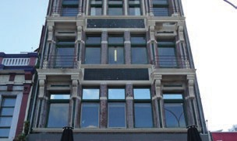
Heritage EQUIP Funded Projects
112

85 Devon Street East, New Plymouth

Grant: $200,000
Grant Type: Upgrade Works Grant
Date funded: May 2018
This building, known as the Red Post Building, has been awarded $200,000 in Heritage EQUIP funding to undertake framing and foundation work.

One of the last remaining heritage buildings in this part of Devon Street East, this building is notable for the fact that a furniture retailer operated from the ground floor for most of the 20th century.
The recent New Plymouth District Council District Plan Review proposes to include the building as a Category A heritage building.

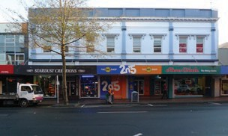
Heritage EQUIP Funded Projects
113

Ashleigh Court, Newtown, Wellington

Grant: $183,171
Grant Type: Upgrade Works Grant
Date funded: September 2018
The upgrade project of Ashleigh Court has been awarded $183,171 in funding, in order for
earthquake strengthening to take place which will see the building achieve 67% of the new building standard (NBS).

Ashleigh Court, which sits at the juncture of Riddiford and Rintoul Streets in Newtown, represents one of suburban Wellington’s most important buildings. Completed in 1908, the three- story stone masonry building was the boldest
and most elaborate project devised by builder- developers John Thomas Hawthorn and Colin Campbell Crump.

Ashleigh Court’s size, height and distinctive triangular shape has meant the building has been a prominent feature of Newtown for over 100 years.
It has always contained ground-level commercial spaces with private accommodation on the upper floors, although the building has been altered over the years to suit different uses.

It is listed as a Category 1 Historic Place by Heritage New Zealand and a heritage listed building in the Wellington City Council district plan.

Strengthening works will include tying the parapets and strengthening unreinforced masonry internal walls. The wider upgrade project has also been supported by Wellington City Council.

New Zealand Heritage List entry – Heritage New Zealand website

Wellington City Council heritage listing

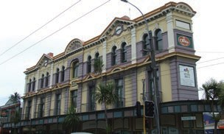
Heritage EQUIP Funded Projects
114

Former Post Office, Onehunga

Grant: $78,118
Grant Type: Upgrade Works Grant
Date funded: September 2018
The Former Post Office is the oldest surviving building in Onehunga’s business centre. It is listed as a Category 2 Historic Place by Heritage New Zealand and a Category A historic heritage place by Auckland City Council.

The building was designed by government architect John Campbell, in the Edwardian Baroque style. It was constructed in 1901 and is an early example of a number of post offices he designed.

The post office operated for over 70 years and, although the building was threatened with demolition in the early 1990s, it survived due to community support.

The current owners have received $78,118 in funding from Heritage EQUIP. The upgrade project will see
a number of elements addressed, including the installation of ceiling bracing, chimney and parapet
strengthening and the strengthening of unreinforced masonry walls. It is anticipated the project will raise the building’s structural rating to 85% NBS.

Once completed, the Post Office will feature space for a ground floor restaurant, with offices or apartments above.

The wider upgrade project has also been supported by the Auckland City Council.

New Zealand Heritage List entry – Heritage New Zealand website

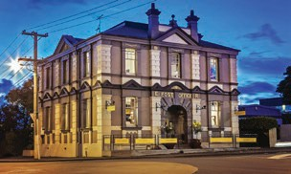
Heritage EQUIP Funded Projects
115

State Cinema, Nelson

Grant: $58,917
Grant Type: Upgrade Works Grant
Date funded: September 2018
The State Cinema project received $58,917 to contribute towards the strengthening of the street- facing front parapet.

The State Chambers Building, which incorporates the State Cinema, is a Category 2 Historic Place and Group B heritage building in the Nelson Resource Management Plan.

This building is one of Nelson’s largest commercial heritage assets and is located on the city’s main shopping thoroughfare, Trafalgar Street. It was built in 1936 out of steel reinforced concrete and has operated as a cinema since that time. It is the only art deco building of significance on the main street.
The Heritage EQUIP grant of $58,917 will support the owners to complete this final stage of the cinema’s ongoing strengthening programme.

New Zealand Heritage List entry – Heritage New Zealand website

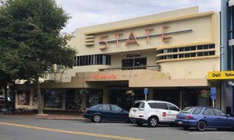
Heritage EQUIP Funded Projects
116

Farmers Building, Wellington

Grant: $250,000
Grant Type: Upgrade Works Grant
Date funded: September 2018
The Farmers building upgrade project has received
$250,000. The building is a Heritage New Zealand Category 2 Historic Place and was designed by Joshua Charlesworth, a prominent local architect who also designed the Wellington Town Hall.

The building was constructed during the First World War from brick masonry and straddles the period between classicism and functional modernism. The building has a high level of original heritage fabric, despite several internal alterations to its layout, and is an excellent example of its time.

The building was initially occupied by Christopher Smith, a draper, until the late 1950s when it was sold to the Farmers Trading Company.

This upgrade project will see the seismic resistance of the Farmers building brought up to 100% NBS and return to commercial use, featuring multiple retail and office spaces. New ground beams, columns and walls will be installed, in order to provide seismic resistance while minimising the removal of heritage fabric.
Heritage fabric within the Farmers building will be retained and restored, including detailed pressed metal ceilings and other components. The exterior façade will also be renovated, with plaster moulds, detailing and wrought iron ties refurbished and retained.

In addition, the strengthening and preservation of the first-floor façade of the neighbouring building at 104 Cuba Street, which is listed under the Wellington District Plan, will take place.

New Zealand Heritage List entry – Heritage New Zealand website

Cuba Street Historic Area – Heritage New Zealand website

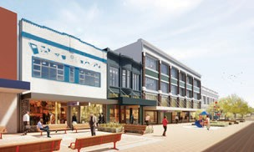
Heritage EQUIP Funded Projects
117

Erskine Chapel, Island Bay, Wellington

Grant: $250,000
Grant Type: Upgrade Works Grant
Date funded: September 2018
The chapel has exceptional architectural, historical and social significance and as such, is listed as a Heritage New Zealand Category 1 Historic Place and recognised in the Wellington City Council Heritage List, while the entire site is subject to a Heritage Order in the council’s district plan.

The chapel sits on the site of the former Erskine College in Island Bay, Wellington. It was designed by John Sydney Swan, one of Wellington’s most important architects of the early twentieth century.

Swan was invited to design the chapel in the 1920s, after originally designing the school’s main block some twenty years earlier. The chapel was constructed using unreinforced brick masonry walls, timber, steel and concrete, during 1929-
30. The result is considered New Zealand’s finest French Gothic-style chapel, with a soaring vaulted ceiling, interior of Italian Carrara marble and exceptional acoustics – it is a light and airy space of undeniable beauty.
This upgrade project will see strengthening work take place to raise the building’s structural rating to 67% NBS, including strengthening unreinforced masonry buttresses with steel, tying back other
unreinforced masonry, strengthening gable end walls with steel rods and installing new steel diaphragms.

Once earthquake-strengthening works are completed, the building will be refurbished and return to use as a function centre and facility for the community to use.

The project has also received funding of $75,000 from Heritage New Zealand.

Building listing – Wellington City Council heritage inventory

New Zealand Heritage List entry – Heritage New Zealand website

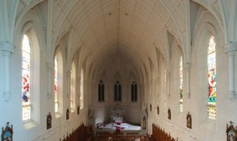
Heritage EQUIP Funded Projects
118

